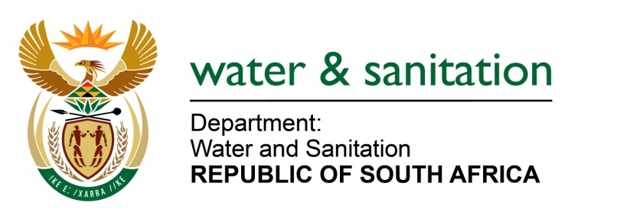

NATIONAL ASSEMBLY

FOR WRITTEN REPLY

QUESTION NO 3488

DATE OF PUBLICATION IN INTERNAL QUESTION PAPER: 30 SEPTEMBER 2022
(INTERNAL QUESTION PAPER NO. 37)

3488. Mrs M O Clarke (DA) to ask the Minister of Water and Sanitation:

(1) Regarding the report on Gravelotte Mines Geotechnical Concerns Pertaining to Flooding in April 2022, what (a) is the reason that his department did not resolve the issue of pumps that were not functioning for the duration of all the respective months, (b)(i) are the details of the service-level agreement for the maintenance of the pumps, (ii) steps were taken in this regard and (iii) were the costs and (c) entity is tasked with restoring the pumps;

(2) whether any local companies have been given tenders for the restoration of the pumps; if not, why not; if so, (a)(i) who are the companies and (ii) what are the details and/or terms of reference of the tenders, (b) what is the timeline of the process at the moment and (c) on what date can pumping resume;

(3) what quantity of acid mine drainage has he found is being released into the Blesbokspruit at the moment?

NW4300E
---00O00---

MINISTER OF WATER AND SANITATION

- The department of Water and Sanitation (DWS) is aware of water from the mine void in the Eastern Basin entering an opencast pit. It should be noted that mining operations are responsible for dewatering their own operations, not the DWS. This responsibility has been recognised by Gold One who are procuring pumps to assist in the pumping and treatment of acid mine drainage in the Eastern Basin.

The Trans-Caledon Tunnel Authority (TCTA) is the implementing agent for DWS on this project. The pumps were procured from Andritz in Germany. Andritz had a proven track record in the supply of these submersible pumps worldwide and the first 2 pumps were donated by Central Rand Gold, who at that stage wished to mine to a depth of 450 m in the Central Basin. Additional pumps were sourced from the same supplier to ensure compatibility and to allow the pumps to be moved between the basins as required.

- Due to Covid-19 and the related global supply chain challenges, TCTA was not able to secure all the spares from Andritz in time to enable the continued pumping at the Eastern Basin AMD Plant. A decision was made to concentrate pumping and treatment in the Western and Central Basins as once the Eastern Basin becomes operational again it has the capacity to recover.

- (i)Nafasi Water Technologies (Pty) Ltd was appointed by the TCTA through a competitive process, on a 5-year contract to operate and maintain the AMD Plants for the Central and Eastern Basins including the AMD pumps.

(ii) The spares for the first motor were received in June 2022 (planned for December 2021) and the refurbishment of the first motor commenced in July 2022 by Marthinus and Coutts and was completed mid-August 2022 as planned. The motor was installed and commissioned by Carl Harm in August 2022 but was only in operation for 1 week before it started stalling and this necessitated the motor to be taken back to the workshop for a detailed inspection.

(iii) The cost of operations and maintenance in the Eastern Basin for the financial year 2021-2022 was R72 million

- The TCTA is responsible for the sourcing of critical spares from the original equipment suppliers in order to maintain the warranties for the various installed equipment.

((i)In addition, the refurbishment of the motors and pumps is being done locally through the following service providers:
- Marthinus & Coutts based in Cleverland, Johannesburg.
- Sulzer - Local Branch
- Carl Harm (Andritz local installer)

(ii-iii) The TCTA in partnership with Gold-One has procured 3 new motors in July 2022 and the factory acceptance tests for the new motors were conducted successfully on 29 September 2022 in China and the motors will be shipped to RSA on 7 October 2022. TCTA is evaluating the option to airfreight one of these motors so that it can be delivered to site within 10 days. Parallel to this process, Sulzer is busy reassembling the pump to be compatible with the new motor from China. If successful, these plans will enable the TCTA to commission one pump by the end of October 2022 and the other two pumps will be commissioned early December 2022.

- TCTA has not released any non-treated acid mine water to the Blesbokspruit since the commencement of operations.

---00O00---

