MINISTRY FOR HUMAN SETTLEMENTS
REPUBLIC OF SOUTH AFRICA

NATIONAL ASSEMBLY

QUESTION FOR WRITTEN REPLY

QUESTION NO.: 3484

DATE OF PUBLICATION: 03 NOVEMBER 2017

Mr N S Matiase (EFF) to ask the Minister of Human Settlements:
With reference to her reply to question 2919 on 17 October 2017, (a) how can the topography not be adequate when there are RDP houses in the area and across the country that are constructed on similar topography and (b) what are the exact details of the location of the site that was suggested (i) for a Mr Sipho Mnguni and (ii) to the four families currently residing on the same site? NW3910E

REPLY:

(a) The Ethekwini Metropolitan Municipality had indicated that the topography of the site on which the property is located is not conducive for the construction of a home within the required standards due to the steepness of the site and limited developable space. Proceeding with the construction of a house will require extensive excavation, levelling and filling to create sufficient space. Furthermore, retaining walls will have to be built on the front and back of the house, to retain the steep banks in order to prevent the house from being damaged during the rainy seasons. The other attendant matter which required attention was the relocation of other families residing in the informal structures on the site to another area before the site could be developed.

In the reply, I have included photographs to illustrate the challenging topography which led to the delay in resolving the matter.

The photograph below indicates the site boundary which extends from the edge of the footpath to where the lower informal structures are located on the site. The limited developable space of the site can be observed (it is where officials are standing), as well as the informal structure on the level portion of site. Note must be taken of the location and proximity of the existing dwellings, to the footpath with running water.
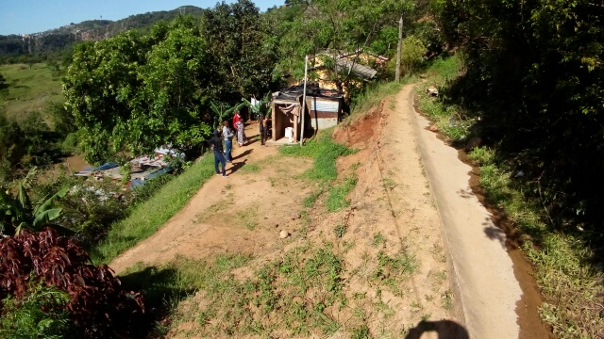

The photograph below illustrates the steepness of the bank and thus the need for the construction of retaining walls.
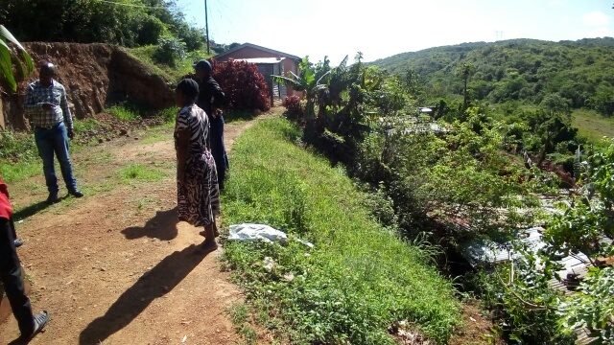

The eThekwini Municipality has now confirmed that after a long protracted consultation, a decision has been taken a decision to build houses for the five families living in the area and a process of identifying alternative accommodation has already commenced. However, it has also been brought to my attention that the said person is not prepared to relocate to a temporary residential area (TRA) to allow for the required planning and construction work to commence.

(b) The property details are as follows:

Site No: Erf 1210, Section F, Umlazi

Coordinates: 30°53'38.175"E 29°56'28.788"S.

Extent: 278m²

