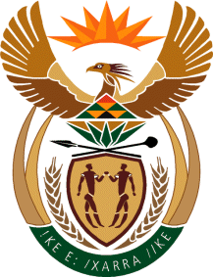

Ministry
Employment & Labour
Republic of South Africa
Private Bag X499, PRETORIA, 0001. Laboria House 215 Schoeman Street, PRETORA Tel: (012) 392 9620 Fax: 012 320 1942
Private Bag X9090, CAPE TOWN, 8000. 120 Plein Street, 12th Floor, CAPE TOWN Tel: (021) 466 7160 Fax 021 432 2830
www.labour.gov.za

NATIONAL ASSEMBLY

WRITTEN REPLY

QUESTION 348 / NW1319E

348. Mr M Hlengwa (IFP) to ask the Minister of Employment and Labour:
Whether he will (a) extend, (b) enforce and (c) ensure that the minimum wage is implemented in the Expanded Public Works Programme; if not, why not; if so, what are the relevant details? NW1319E
REPLY:
The workers under the Expanded Public Workers Programme are already included within the scope of the National Minimum Wage Act albeit at a lower tier/percentage of the NMW as is the case for domestic and farm workers. The minimum wage for these workers has been set at R11 per hour or 55% of the national minimum wage as contemplated in item 2 (c ) of Schedule 1 of the Act, taking into account the ability of the State to fund these work opportunities, retain the number of participants and provide some level of income security as an integral part of the Governments plans to address poverty alleviation. Section 4 (3) of the Act provides that the minimum wage in respect of these workers will be increased proportionally to any adjustment of the national minimum wage
Just as any other piece of labour legislation it is the employer’s responsibility to implement and comply with it. The Department is enforcing the NMW in all its facets.

