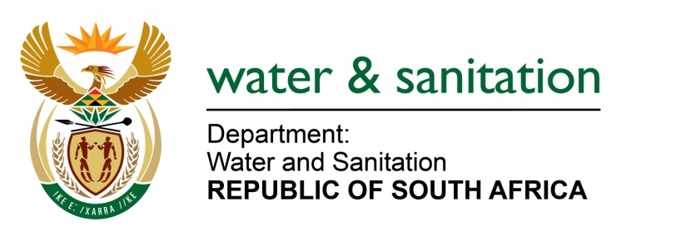

NATIONAL ASSEMBLY

FOR WRITTEN REPLY

QUESTION NO 3475

DATE OF PUBLICATION IN INTERNAL QUESTION PAPER: 30 SEPTEMBER 2022
(INTERNAL QUESTION PAPER NO. 37)

3475. Ms S A Buthelezi (IFP) to ask the Minister of Water and Sanitation:
In light of the fact that the first National Resources Strategy review was published in 2004 and the second in 2013 and that legislation stipulates that the National Resources Strategy must be reviewed every five years, on what date will the third review of the strategy be published as irregular monitoring and strategising results in the mismanagement of water resources services and infrastructure?
NW4280E
---00O00---

MINISTER OF WATER AND SANITATION

The NWRS-3 will be finalised and approved on 31 March 2023 as outlined on the Department’s Annual Performance Plan.

The Department is currently conducting public consultation workshops on the draft National Water Resource Strategy 3 (NWRS-3) as required by the National Water Act (NWA). Call for public consultation was done through the Gazette Notice which was published on 27 July 2022 under Notice 47133. After public consultation, the document will be updated based on the comments received from various stakeholders and a final document will be submitted to Cabinet for approval.

While there has been a delay in finalising and publishing the NWRS-3, the NWRS-2 is still being implemented by the Department, it’s entities as well as the entire water and sanitation sector stakeholders. Therefore, the Department has not neglected its responsibility to protect, use, develop, conserve, manage and control the country’s water resources.

---00O00---

