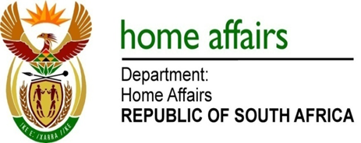

NATIONAL ASSEMBLY

QUESTION FOR WRITTEN REPLY

QUESTION NO. 347

DATE OF PUBLICATION: 22, FRIDAY, FEBRUARY 2019

INTERNAL QUESTION PAPER 3 OF 2019

347. Mr D Bergman (DA)) to ask the Minister of Home Affairs:

With reference to the undertaking of the President of the Republic, Mr M C Ramaphosa, on 21 September 2018 to drop the requirement for certain countries to hold visas in order to enter the country, (a) what are the names of the countries and (b) by what date will citizens of these countries be able to travel to the country without holding a visa? NW371E

REPLY:

(a) On 25 September 2018, the Department of Home Affairs announced that discussions were taking place to conclude Visa Waiver Agreements with the following countries: Algeria, Egypt, Morocco, Sao Tome & Principe, Tunisia, Saharawi, Ghana, Saudi Arabia, UAE, Qatar, Palestine, Iran, Lebanon, Bahrain, Oman, Kuwait, Belarus, Georgia & Cuba.

(b) Negotiations are being finalised to conclude Visa Waiver Agreements by April 2019. An Official announcement will be made in this regard once the relevant countries have been notified through Diplomatic Channels.

