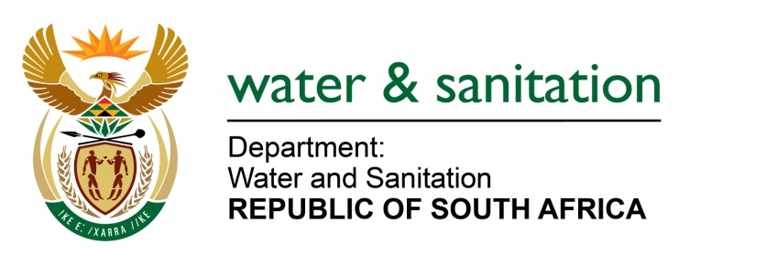

NATIONAL ASSEMBLY

**FOR WRITTEN REPLY**

**QUESTION NO 3469**

**DATE OF PUBLICATION IN INTERNAL QUESTION PAPER: 16 OCTOBER 2015**

**(INTERNAL QUESTION PAPER NO. 40)**

**3469. Ms A Steyn (DA) to ask the Minister of Water and Sanitation:*[Interdepartmental transfer from Cooperative Governance and Traditional Affairs on 16 October 2015*]**

(a) What total amount of the R300 million that was provided to KwaZulu-Natal for drought relief has been spent, (b) what amount was spent in each affected municipality and (c) what are the relevant details of the specific relief that was provided through the specified funds in respect of each municipality? NW4130E

---00O00---

**REPLY:**

1. A total of R443.765 million has been allocated by my Department for drought interventions for KwaZulu-Natal Province. The amount of this R172.219 million has been spent as follows:

* R66,9 million on the purchase of 45 water tankers;
* R19,733 million payments being processed; and
* R85,512 million already paid.

1. A summary of the amounts spent in each Municipality is provided in **Table 1** below. Refer to **Table 2** for expenditure for each project type in each Water Services Authority.

**Table 1**: Drought relief funding



1. The drought relief interventions include the following different project types:
   * purchase of water tankers
   * installation of static water tanks
   * spring protection
   * refurbishment and upgrade of water supply systems
   * development of boreholes
   * water tanker rental
   * interim water tanker rental
   * programme management

---00O00---

**Table 2** below indicates the expenditure for each project type in each Water Services Authority.

**Table 2: KwaZulu-Natal drought intervention budget and expenditure**

---00O00---

