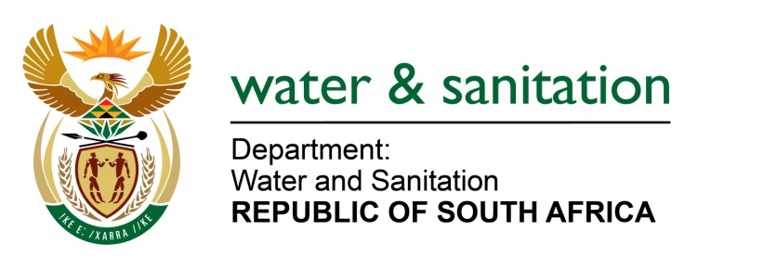

NATIONAL ASSEMBLY

FOR WRITTEN REPLY

QUESTION NO 3463

DATE OF PUBLICATION IN INTERNAL QUESTION PAPER: 30 SEPTEMBER 2022
(INTERNAL QUESTION PAPER NO. 37)

3463. Ms S A Buthelezi (IFP) to ask the Minister of Water and Sanitation:
Whether, in light of the fact that regular water quality monitoring and water infrastructure assessments are crucial to reduce the increased risk of the contraction of water-borne diseases, the degradation of ecosystems and major physical water losses and the blue and green dot reports that show clearly that monitoring does not take place consistently, he has been informed of the lapse in the water quality monitoring function of his department; if not, what is the position in this regard, if so, what steps will his department take to rectify the issue?
NW4268E

---00O00---

MINISTER OF WATER AND SANITATION

There are several programmes through which the Department of Water and Sanitation (DWS) monitors adverse water quality impact on the country’s water resources such as the:
- National Chemical Monitoring Programme (NCMP)
- National Eutrophication Monitoring Programme (NEMP)
- National Microbial Monitoring Programme (NMMP)
- River Eco-status Monitoring Programme (REMP)
- National Estuaries Monitoring Programme (NEsMP)

Sludge monitoring is also essential as poor sludge handling is the root cause of many Wastewater Treatment Works (WWTWs) failing to meet final effluent standards. The results indicate that the municipalities on average are not achieving regulatory norms and standards. The data from the Green Drop Report indicated that 64% of all Water Services Authorities (WSAs) have access to credible laboratories for compliance and operational analysis. These in-house or contracted laboratories have been accredited and have Proficiency Testing Schemes with suitable analytical methods and quality assurance. The remaining 46% of WSAs are not meeting the regulatory norms and standards in terms of which they should have access to analytical services for compliance, operational and sludge monitoring.

To improve this situation, the department has developed the Water Services Improvement Programme and is progressively implementing programmes to support municipalities together with the Municipal Infrastructure Support Agent (MISA) and South Africa Local Government Association (SALGA).

---00O00---

