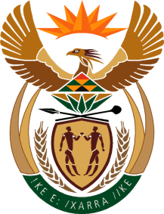

**MINISTRY OF TOURISM**

**REPUBLIC OF SOUTH AFRICA**

Private Bag X424, Pretoria, 0001, South Africa. Tel. (+27 12) 444 6780, Fax (+27 12) 444 7027

Private Bag X9154, Cape Town, 8000, South Africa. Tel. (+27 21) 469 5800, Fax: (+27 21) 465 3216

**NATIONAL ASSEMBLY:**

**QUESTION FOR WRITTEN REPLY:**

**Question Number: 3463**

**Date of Publication: 9 November 2018**

**NA IQP Number: 39**

**Date of reply: 22 November 2018**

**Ms C King (DA) to ask the Minister of Tourism:**

(1) (a) On what date did his department last conduct an audit of artwork owned by Government which is under his department’s curatorship and (b) what are the details of each artwork under the curatorship of his department according to the Generally Recognised Accounting Practice 103;

(2) whether any artworks under his department’s curatorship have gone missing (a) in each of the past five financial years and (b) since 1 April 2018; if so, what are the relevant details? NW3952E

**Reply**

**1(a) Date of last audit of artwork owned by the Department of Tourism**

The last audit of artwork was done before 31 March 2018.

**(b) What are the details of each artwork under the curatorship of the department?’**

The artwork is accounted for in accordance with the Modified Cash Standard issued by National Treasury and applicable to government departments.



**(2) Artwork that went missing:**

(a) –(b) The Department has no artwork that went missing for the requested financial years.