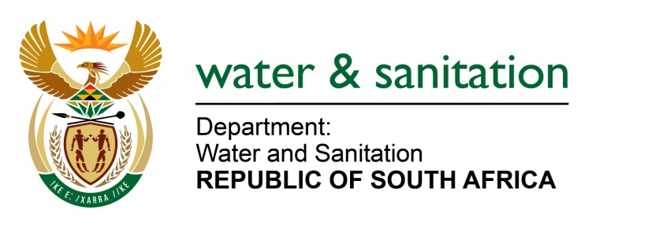

NATIONAL ASSEMBLY

FOR WRITTEN REPLY

QUESTION NO 3462

DATE OF PUBLICATION IN INTERNAL QUESTION PAPER: 3 NOVEMBER 2017
(INTERNAL QUESTION PAPER NO. 41)
3462. Ms M S Khawula (EFF) to ask the Minister of Water and Sanitation:
(1) How many officials and/or employees in her department were granted permission to have businesses and/or do business dealings in the past three financial years;
(2) are any of the officials and/or employees that have permission to have businesses and/or do business dealings doing business with the Government; if so, (a) what was the purpose of each business transaction, (b) when did each business transaction occur and (c) what was the value of each business transaction? NW3888E
---00O00---
REPLY:
(1) A total of 67 officials and/or employees in my Department have been granted permission to have businesses.
(2) No officials and/or employees have permission to do business with Government.
---00O00---

