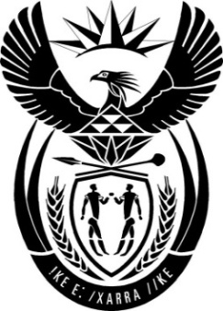

THE PRESIDENCY:

REPUBLIC OF SOUTH AFRICA

Private Bag X1000, Pretoria, 0001, Tel: 012 300 5200 / Private Bag X 1000, Cape Town, 8000, Tel: 021 464 2100

NATIONAL ASSEMBLY

QUESTION FOR WRITTEN REPLY

QUESTION NO.: 346.

Mr J J McGluwa (DA) to ask the Minister in The Presidency:
What steps will be taken against persons in the employ of the State Security Agency who have been found guilty of misconduct and the abuse of State resources in terms of the Intelligence Services Act, Act 65 of 2002? NW357E
REPLY:
In terms of section 18(2) of the Intelligence Services Act, 2002 “a member may be discharged from the Agency or demoted by the Director-General if, after a hearing in the prescribed manner as to his or her fitness to remain in employment or to retain his or her rank or grade, the Director-General is of the opinion that such member is guilty of misconduct.” However, there are other sanctions that the Director-General may impose in respect of a member who has been found guilty of misconduct, as provided for in Regulation 14 of Chapter XVIII of the Intelligence Services Regulations, 2014.

When a member of the SSA is found to have committed financial misconduct that has resulted in financial loss for the Agency, the matter is referred to the relevant law enforcement Agency for investigation, as contemplated in section 86 of the Public Finance Management Act, 1999, read with Regulation 4 of the Treasury Regulations.

