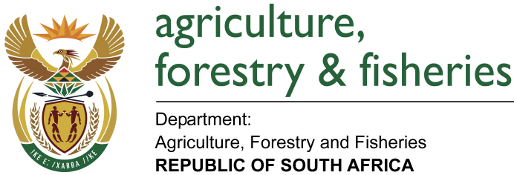
NATIONAL ASSEMBLY

WRITTEN REPLY

QUESTION 346 / NW399E

MINISTER OF AGRICULTURE, FORESTRY AND FISHERIES:

Mr T. C. R Walters (DA) to ask the Minister of Agriculture, Forestry and Fisheries:

QUESTION:
What is the (a) make, (b) model, (c) price and (d) date on which each vehicle was purchased for use by (i) him and (ii) his deputy (aa) in the (aaa) 2014-15 and (bbb) 2015-16 financial years and (bb) since 1 April 2016? NW399E

REPLY:
- Minister - (Mr) S Zokwana, MP | - Make | - Model | - Price | - Date of purchase | aaa)
Cape Town | Audi | Q7 3.0 TDi Q Tip | R630 953.38 | 26 August 2014 | Bought in 2014/2015 financial year
Pretoria | Audi | Q7 3.0 TDi Q Tip | R626 199.72 | 26 August 2014 | Bought in 2014/2015 financial year

bbb) No procurement of official vehicles in 2015/2016.
bb) No procurement of official vehicles since 01 April 2016.
- Deputy Minister - Gen Bheki Cele, MP | - Make | b) Model | c) Price | - Date of purchase | aaa)
Cape Town | Jeep | Grand Cherokee | R622 661.00 | 19 August 2014 | Bought in 2014/2015
Pretoria | Jeep | Grand Cherokee | R622 661.00 | 14 August 2014 | Bought in 2014/2015

bbb) No procurement in 2015/2016.
bb) No procurement since 01 April 2016.

