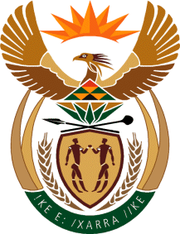

MINISTRY: COMMUNICATIONS
REPUBLIC OF SOUTH AFRICA
Private Bag X 745, Pretoria, 0001, Tel: +27 12 473 0164 Fax: +27 12 473 0585
Tshedimosetso House,1035 Francis Baard Street, Tshedimosetso House, Pretoria, 1000

NATIONAL ASSEMBLY
QUESTION FOR WRITTEN REPLY
QUESTION NUMBER: 3450 of 2015
DATE OF PUBLICATION: SEPTEMBER 2015
Ms V van Dyk (DA) to ask the Minister of Communications:
When does she intend to introduce the Media Development and Diversity Agency’s amending Bill in Parliament?

REPLY: MINISTER OF COMMUNICATIONS
The Department anticipates that the MDDA Amendment Bill will be introduced in Parliament during the fourth (4) quarter of 2015/16 Financial year

MR NN MUNZHELELE
DIRECTOR GENERAL [ACTING]
DEPARTMENT OF COMMUNICATIONS
DATE:

MS AF MUTHAMBI (MP)
MINISTER OF COMMUNICATIONS
DATE:

