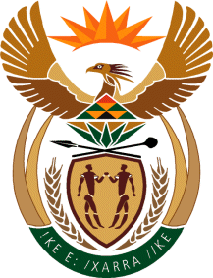
MINISTRY
SPORT AND RECREATION
REPUBLIC OF SOUTH AFRICA

Department of Sport and Recreation l Private Bag X896 l PRETORIA l 0001 l Regent Place l 66 Queen Street l Pretoria l 0001 l +27 (0)12 304 5158 l Fax: +27 (0)12 323 8426
Private Bag X9149 l Cape Town l 8000 l 2nd Floor Parliament Building l 120 Plain Street l CAPE TOWN l Tel: +27 21 469 5705 l Fax: +27 21 465 4402
www.srsa.gov.za
_____________________________________________________________________

NATIONAL ASSEMBLY

WRITTEN REPLY

QUESTION PAPER: No. 41 of 03 NOVEMBER 2017

DATE OF REPLY: 15 DECEMBER 2017

3449. Mr P G Moteka (EFF) asked the Minister of Sport and Recreation:
(1) How many officials and/or employees in his department were granted permission to have businesses and/or do business dealings in the past three financial years;

(2) are any of the officials and/or employees that have permission to have businesses and/or do business dealings doing business with the Government; if so, (a) what was the purpose of each business transaction, (b) when did each business transaction occur and (c) what was the value of each business transaction? NW3875E
______________________________________________________________________
The Minister of Sport and Recreation

REPLY:

(1) There were 22 employees who submitted applications for remunerative work outside of official hours, and were covered in terms of the Public Service Act, 1994, Section 30, Subsection 3(b), as no formal permission was granted by the Executive Authority.

(2)(a), (b) and (c) None of the 22 employees have declared any business dealings with Government.

