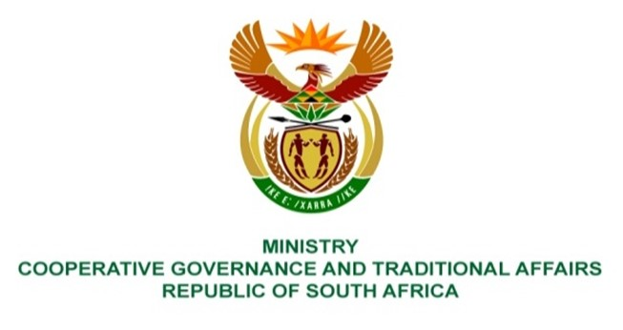

NATIONAL ASSEMBLY
QUESTION FOR WRITTEN REPLY

QUESTION NUMBER 3445
DATE OF PUBLICATION: 30 SEPTEMBER 2022

3445. Mr K Ceza (EFF) to ask the Minister of Cooperative Governance and Traditional Affairs:
By what date will the training of senior managers in the (a) Kagisano Molopo, (b) Ditsobotla, (c) Lekwa-teemane, (d) Mamusa and (e) Greater Taung Local Municipalities that are in the (i) Dr Ruth Segomotsi Mompati District Municipality and (ii) Ngaka Modiri Molema District Municipality be completed by her department in order to capacitate municipal managers, senior managers and asset managers?
Reply:
The question by Honourable Member does not indicate what kind or type of training referred to in the above question. It is recommeded that the member be specific on what type of training is referring to in order for the department to respond accordingly.

