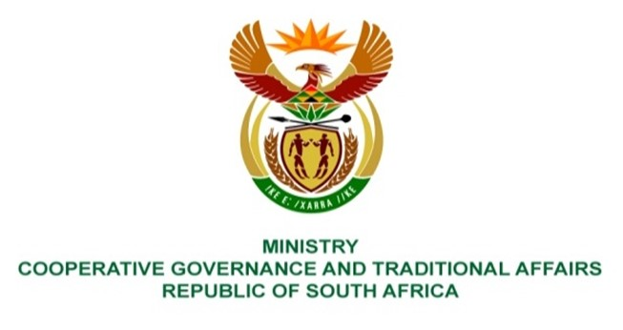

NATIONAL ASSEMBLY
QESTION FOR WRITTEN REPLY

QUESTION NUMBER 3444
DATE OF PUBLICATION: 30 SEPTEMBER 2022

QUESTION:

3444. Mr K Ceza (EFF) to ask the Minister of Cooperative Governance and Traditional Affairs:
In light of the failure of the Municipal Managers from (a) Mamusa Local Municipality and (b) Maquassi Hills Local Municipality, what outcomes does her department intend for the section 139(7) constitutional intervention to yield in the North West? NW4249E

REPLY:
The Maquassi Hills and Mamusa Local Municipalities are currently not under intervention in terms of Section 139 (7) of the Constitution of the Republic of South Africa.

