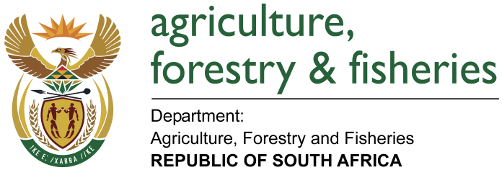
NATIONAL ASSEMBLY

WRITTEN REPLY

QUESTION 3436 / NW 3925E

MINISTER OF AGRICULTURE, FORESTRY AND FISHERIES:
Mr J H Steenhuizen (DA) to ask the Minister of Agriculture, Forestry and Fisheries:

QUESTION:
(1) (a) On what date did his department last conduct an audit of artwork owned by Government which is under his department’s curatorship and (b) what are the details of each artwork under the curatorship of his department according to the Generally Recognised Accounting Practice 103;
(2) whether any artworks under his department’s curatorship have gone missing (a) in each of the past five financial years and (b) since 1 April 2018; if so, what are the relevant details? NW 3925E
REPLY:
For the past ten (10) financial years artwork was not identified as a high risk area to be audited and therefore no internal audits were conducted of artwork owned by Government which is under the Minister’s department’s curatorship. Although no internal audits were done there are regular stock takes of assets performed by the Directorate: Asset Management. The latest stock take conducted on the artwork in the Ministry office in Cape Town was on 20 September 2017 and no discrepancies were found.

Currently there are five artwork paintings and all five of them are currently in room 106 in Cape Town. Please refer to the attached document for the details as per the stock take conducted on 20 September 2017.

