FOR WRITTEN REPLY

NATIONAL ASSEMBLY
36/1/4/1(2018)

QUESTION 3434

DATE OF PUBLICATION IN INTERNAL QUESTION PAPER: 9 NOVEMBER 2018 NTERN L UESTION PAP R NO 3 2 1

3434. Mrs A M Dreyer (DA) to ask the Minister of Police:

By what date wit a new police station be built for the Boksburg North police precinct?
NW3923E
REPLY:

The Construction of the Police station in Boksburg North, forms part of the Top 10 Priorities of the Gauteng Province.

The Department of Public Works has already identified a site and this office commenced with site clearance in June 2018.

The site clearance is scheduled to be finalised by 2020/2021.

The planning and design to be finalised by 2021/2022 whereafter the execution will commence

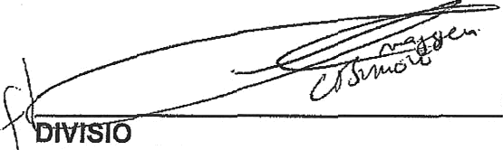
LIEUTENANT GENERAL NAL COMMISSIONER: SUPPLY CHAIN MANAGEMENT
RJ MOKWENA
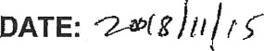

Reply to question 3434 recommended/

-— LIEUTENANT GENERAL DEPUTY NATIONAL COMMISSIONER: ASSET AND LEGAL MANAGEMENT FN VU£IIA

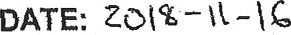

DATE OF PUBLICATION IN INTERNAL aUE TION PAPER: 9 NOVEMBER 2018 (INTERNAL QUESTION PAPER NO 39-2018)

Reply to question 3434 recommended/not recommended

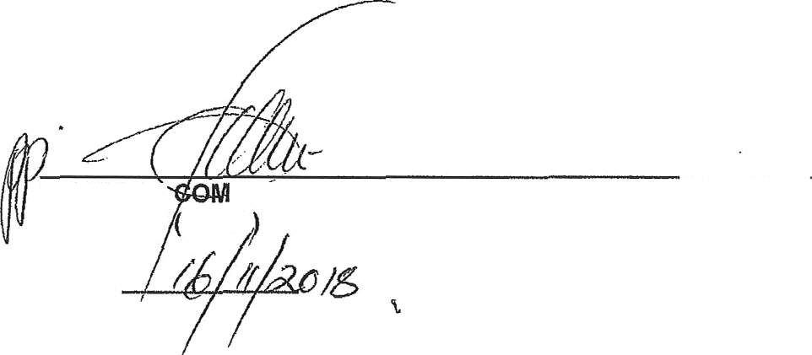
NATIONAL
GENERAL MISSIONER: SOUTH AFRICAN POLICE SERVICE
KJ SITOLE SOEG

DATE:

Reply to question 3434 approved/me

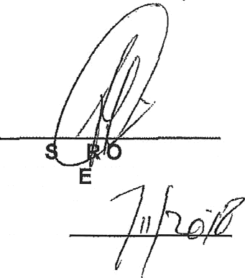

MINI BE F POLICE BH CEL , MP

DATE:

