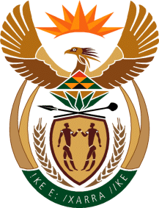

MINISTRY: PUBLIC SERVICE AND ADMINISTRATION
REPUBLIC OF SOUTH AFRICA

NATIONAL ASSEMBLY

QUESTION FOR WRITTEN REPLY

DATE: 30 SEPTEMBER 2022

QUESTION NO.: 3432.

Mrs C C S Motsepe (EFF) to ask the Minister of Public Service and Administration:
Whether he has been informed that departments are delaying pension payouts to retired employees, while the human resource offices want bribes in order to fast-track payment which is due to retired employees; if not, what is the position in this regard; if so, what steps have been taken to uproot the corrupt practice? NW4234E

REPLY:

The Acting Minister for the Public Service and Administration is not aware of the alleged unethical conduct by some human resources offices who want bribes in order to fast-track payment, which is due to retired employees. Employees who are approached to pay bribes, should report that immediately to the SAPS, as it is a criminal offence.
The affected employees can report the alleged corrupt practice to the National Anti-Corruption Hotline 0800 701 701 which is managed by the Public Service Commission, for investigation.
In addition, on 23 September 2022, the Department of the Public Service and Administration (DPSA) issued Circular 47 of 2022, attached herein, on the exit procedure to assist human resources personnel responsible for exits in the Public Service.

Furthermore, the Government Pensions Administration Agency (GPAA) is collaborating with the National School of Government (NSG) to introduce a module aimed at improving and fast-tracking exits in the Public Service.
End

