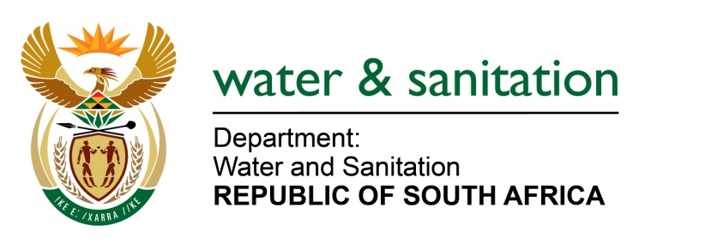

NATIONAL ASSEMBLY

FOR WRITTEN REPLY

QUESTION NO 342

DATE OF PUBLICATION IN INTERNAL QUESTION PAPER: 16 FEBRUARY 2018
(INTERNAL QUESTION PAPER NO. 2)

342. Mr H B Groenewald (DA) to ask the Minister of Water and Sanitation:

What amount did (a) her department and (b) each entity reporting to her spend on the promotion or celebration of the Year of O R Tambo on the (i) Africa News Network 7 channel, (ii) SA Broadcasting Corporation (aa) television channels and (bb) radio stations, (iii) national commercial radio stations and (iv) community (aa) television and (bb) radio stations since 1 January 2017? NW364E
---00O00---
REPLY:
There was no amount spent by my Department and each entity reporting to me towards celebrations of the Year of OR Tambo.
---00O00---

