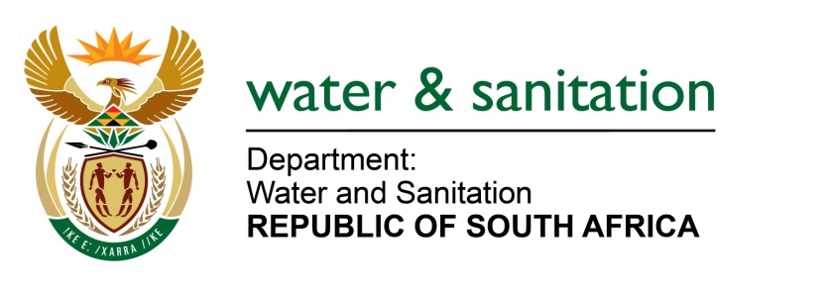

NATIONAL ASSEMBLY

FOR WRITTEN REPLY

QUESTION NO 3419

DATE OF PUBLICATION IN INTERNAL QUESTION PAPER: 11 SEPTEMBER 2015
(INTERNAL QUESTION PAPER NO. 37)
3419. Ms L L van der Merwe (IFP) to ask the Minister of Water and Sanitation:
Whether her department meets the Government’s 2% employment equity target for the employment of persons with disabilities that was set in 2005; if not, why not; if so, what are the relevant details? NW4080E
---00O00---
REPLY:

Currently, my Department is not meeting the set targets of 2% for the employment of people with disabilities.

However my Department has in 2012, established an Employment Equity (EE) Forum which developed and an approved EE Plan to address issues of gender and disability.

Since the inception of the forum in 2012 there has been a slow but significant movement in the appointment of people with disabilties from 0.28% in April 2011 to 0.76% as at April 2014. Currently, the percentatge of people with disabilities as at July 2015 is 0.78%. (see below movement of appointment PWDs)

My Department plans to target vacant funded posts when advertising for people with disabilities in the future to reach the target of 2% or more, and also work closely with the Directorate Gender and Mainstreaming to address isues of gender and disabilities.
---00O00---

