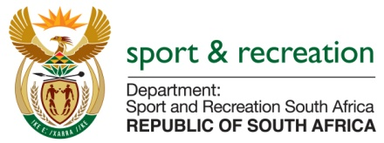

PARLIMENTARY QUESTION FOR THE MINISTER

QUESTION NUMBER 3414

QUESTION
Mr K P Sithole (IFP) to ask the Minister of Sport and Recreation:

In light of the 2022 Commonwealth Games that the country will host, does his department have any programmes in place to promote these games in the rural areas; if not, why not; if so, what are the relevant details? NW4075E

REPLY

In the next 7 years all relevant programmes of the Department, including the conditional grant framework will be aligned to the delivery on amongst other, the legacy of the Commonwealth Games 2022 for the country.
In this vein, it is envisaged that the club development programme that is being piloted in 2 provinces presently will be rolled out in the other provinces, targeting mainly the rural areas.
Within these programmes, there will be capacity development initiatives, the provision of equipment and attire and formation of clubs and local sports structures

Through a targeted approach basic sport and recreation infrastructure will be rolled out to those areas most in need.

Sport and Recreation South Africa will work closely with the local Organising Committee to ensure that rural areas are also beneficiaries to other initiatives.

