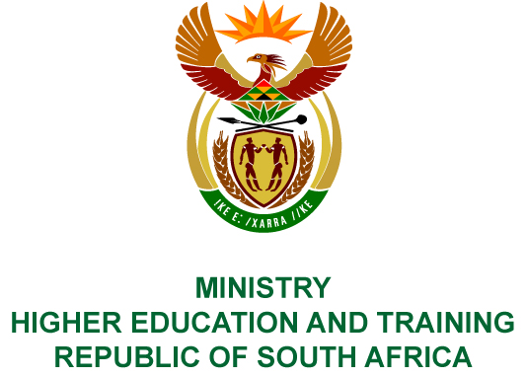
Private Bag X893, Pretoria, 0001, Tel (012) 312 5555, Fax (012) 323 5618
Private Bag X9192, Cape Town, 8000, Tel (021) 469 5150, Fax: (021) 465 7956
Memorandum from the Parliamentary Office
NATIONAL ASSEMBLY
FOR WRITTEN REPLY
QUESTION 34
DATE OF PUBLICATION OF INTERNAL QUESTION PAPER: 08/02/2018

(INTERNAL QUESTION PAPER NO 1 OF 2018)
Mrs A M Dreyer (DA) to ask the Minister of Higher Education and Training:
(a) What is the (i) nature and (ii) level of support given by the Chemical Industries Education and Training Authority to each provincial education department, (b) which provincial education departments are currently benefiting from the initiatives and (c) on what basis are the specified provincial departments of education selected?
NW39E

REPLY:
The Chemical Industries Education and Training Authority (CHIETA) has provided the following responses to the questions posed.
- During the current financial year, CHIETA has:
- Provided the Department of Education in the Free State Province with Mathematics and Science support for high school learners and bursaries for unemployed individuals.
- There are 199 beneficiaries.
- Only the Free State Department of Education is currently benefiting from the CHIETA initiatives.
- Funding opportunities were made public and the Free State Department of Education was the only provincial education department that submitted an application.

COMPILER DETAILS
NAME AND SURNAME: MR MABUZA NGUBANE
CONTACT: 012 312 5248
RECOMMENDATION
It is recommended that the Minister signs Parliamentary Question 34.

MR GF QONDE
DIRECTOR–GENERAL: HIGHER EDUCATION AND TRAINING
DATE:

PARLIAMENTARY QUESTION 34 IS APPROVED / NOT APPROVED / AMENDED.
COMMENT/S

PROF HB MKHIZE, MP
MINISTER OF HIGHER EDUCATION AND TRAINING
DATE:

