NATIONAL ASSEMBLY
36/1J4/1(201800337)

FOR WRITTEN REPLY QUESTION 3395
DATE OF PUBLICATION IN INTERNAL QUESTION PAPER: 9 NOVEMBER 2018 (INTERNAL QUESTION PAPER NO 39-2018)

3395. Mr D W Macpherson (DA) to ask the Minister of Police:

With reference to his reply to question 2844 on 31 October 2018, what number of cases were reported for each category?
NW3884E
REPLY:

The number of cases, which were reported, at the Umhlali Police Station, in the 2017/2018 financial year, is as follows:

 | Offence | Total reported
(a) | Murder | 34
(b) | A4empted murder | 31
(c) | Rapes | 77
(d) | Housebreaking (residential and businesses) | 326
(e) | Hijacking (vehicles and trucks) | 2
(f) | Theft of motor vehicles and motor cycles | 61
(g) | House robbery | 19

Original signed LIEUYENANT GENERAL DIVISIONAL COMMISSIONER: DETECTIVE SERVICE TC MOSIKILI

Date: 12 November 2018
Reply to question 3395 recommended

Original signed LIEUTENANT GENERAL DEPUTY NATIONAL COMMISSIONER: CRIME DETECTION M TSUMANE

Date: 12 November 2018

2

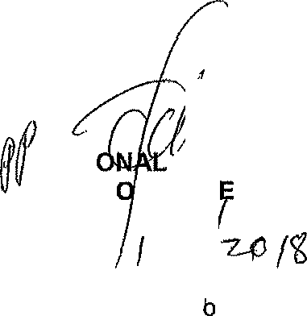
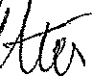
Reply to question 3395 recommended/no c red

GENERAL NATI COMMISSIONER: SOUTH AFRICAN POLICE SERVICE KJ SIT LE 0 G)

Date: /)

Reply to questi n 3395 approved/notappfo.v

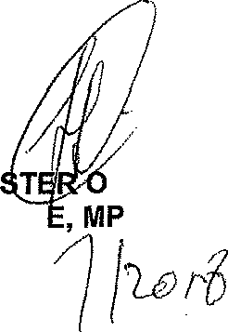
MINI BH CEL
F POLICE

Date: j‹

