FOR WRITTEN REPLY

NATIONAL ASSEMBLY
36/1/4/1(201800340)

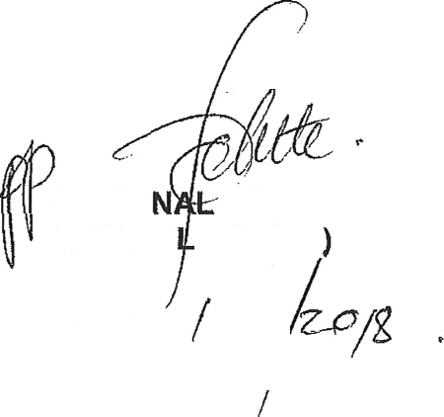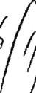
QUESTION 3394

DATE OF PUBLICATION IN INTERNAL QUESTION PAPER: 9 NOVEI\/IBER 2018 (INTERNAL QUESTION PAPER NO 39-2018)

3394. Mr M W Rabotapi (DA) to ask the Minister of Police:

What number of (a) cases of (i) murder, (ii) rape, (iii) housebreaking, (iv) carjacking,
(v) theft of motor vehicles, (vi) house robbery and (vii) drug-related crimes were (aa) reported at the Boksburg North Police Station, (b) such cases were sent to court and
(c) convictions were obtained for the specified cases in the past three financial years?
NW3883E
REPLY:

(a)  Boksburg North | (b)  Cases to court |  |  | (c)  Convictions
 | 2015/16 | 2016/17 | 2017/18 | 2015/16 | 2016/17 | 2017/18
(i) Murder | 11 | 09 | 09 | 05 | 02 | 01
(ii) Rape | 17 | 16 | 28 | 40 | 07 | 06
(iii) Housebreaking | 451 | 480 | 380 | 14 | 14 | 09
(iv) Carjacking | 48 | 91 | 80 | 03 | 00 | 00
(v) Theft of motor  vehicles | 472 | 441 | 394 | 05 | 03 | 00
(vi) House Robbery | 61 | 48 | 62 | 02 | 01 | 00
(vii) Drug-related  crimes | 726 | 691 | 777 | 246 | 241 | 229

Reply to question 3394 recommended/nod

GENERAL NATtO COMMISSIONER: SOUTH AFRICAN POLICE SERVICE KJ SITO E (SOEG

Date:

2

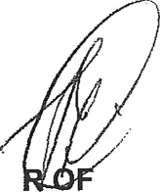
Reply to question 3394 approved/ app o e

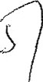MINISTE POLICE BH CELE, MP

