36/1/4/1(201800339)
NATIONAL ASSEMBLY

FOR WRITTEN REPLY

QUESTION 3393

DATE OF PUBLICATION IN INTERNAL QUESTION PAPER: 9 NOVEMBER 2018 (INTERNAL QUESTION PAPER NO 39-2018)

3393. Prof B Bozzoli (DA) to ask the Minister of Police:

What number of (a) cases of (i) murder, (ii) rape, (iii) housebreaking, (iv) carjacking,
(v) theft of motor vehicles, (vi) house robbery and (vii) drug-related crimes were (aa) reported at the Dawn Park Police Station, (b) such cases were sent to court and (c) convictions were obtained for the specified cases in the past three financial years?
NW3882E
REPLY:

(a)  Dawn Park |  | (b)  Gases to court |  |  | (c)  Convictions
 |  | 2015/16 | 2016/17 | 2017/18 | 20'I5/18 | 2016/17 | 2017/18
(i) Murder |  | 13 | 10 | 03 | 03 | 02 | 00
(il) Rape |  | 27 | 15 | 18 | 08 | 02 | 00
(III)  Housebreaking |  | 26 | 34 | 03 | 08 | 02 | 01
(iv) Caracking |  | 09 | 04 | 01 | 02 | O2 | 00
(v) Theft of motor  vehicles |  | 10 | 04 | 01 |  | OO | 00
(vi | House robbery | 07 | 04 | 01 | 01 | 00 | 00
(vii) Drug-related  crimes |  | 87 | 153 | 188 | 18 | 27 | 27

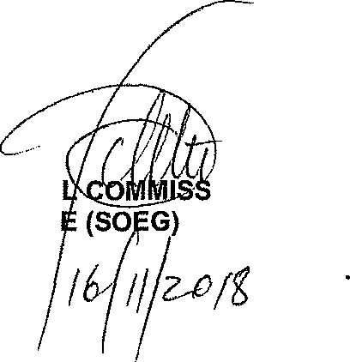
Reply to question 3393 recommended/not recommended

NATIONA KJ SITOL

Date:
GENERAL IONER: SOUTH AFRICAN POLICE SERVICE

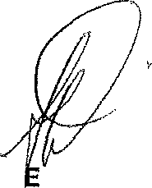
Reply to question 3393 approved/n

MINIST R OF POLICE BH CELE P

