36/1/4/1(201800338)
NATIONAL ASSEMBLY

FOR WRITTEN REPLY QUESTION 3392
DATE OF PUBLICATION IN INTERNAL QUESTION PAPER‹ 9 NOVEMBER 2018 (INTERNAL QUESTION PAPER NO 39-2018)

3392. Prof B Bozzoli (DA) to ask the Minister of Police:

What number of (a) cases of (i) murder, (ii) rape, (iii) housebreaking, (iv) carjacking,
(v) theft of motor vehicles, (vi) house robbery and (vii) drug-related crimes were (aa) reported at the Relger Park Potice Station, (b) such cases were sent to court and (c) convictions were obtained for the specified cases in the past three financial years?
NW3881E
REPLY:

 | (a)  Reiger Park |  | (b)  Cases to court |  |  | (c)  Convictions
 |  |  | 2015/16 | 2016/17 | 2017/18 | 2015/16 | 2016/17 | 2017/18
 | (i) Murder |  | 11 | 9 | 9 | 08 | 04 | 04
 | (I) Rape |  | 17 | 16 | 28 | 04 | 09 | 03
 | (ii | ) Housebreaking | 451 | 480 | 380 | 00 | 00 | 01
 | (iv | Car]acking | 48 | 91 | 80 | 01 | 00 | 00
 | (v)Theft of motor  vehicles |  | 472 | 441 | 394 | 00 | 00 | 01
 | (vi)House robbery |  | 61 | 48 | 62 | 00 | 00 | 01
 | ii)Drcrg=relatecf»  crimes |  | 72a | —691 — | 7 | —- 32 |  | ——48

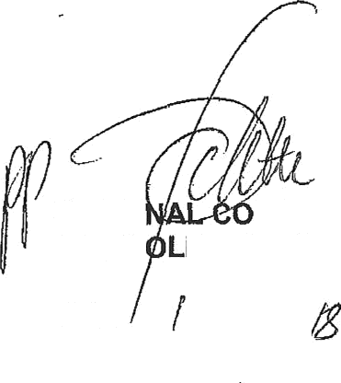
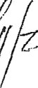
Reply to question 3392 recommended/not recommended

GENERAL NATIO MMISSIONER: SOUTH AFRICAN POLICE SERVICE KJ SIT E(SOEG)

Dafe: j/

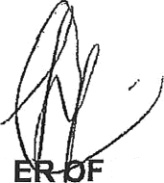
Reply to question 3392 approved/ app ed

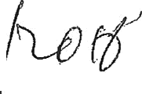
MINIST POLICE BH CELE,
M

