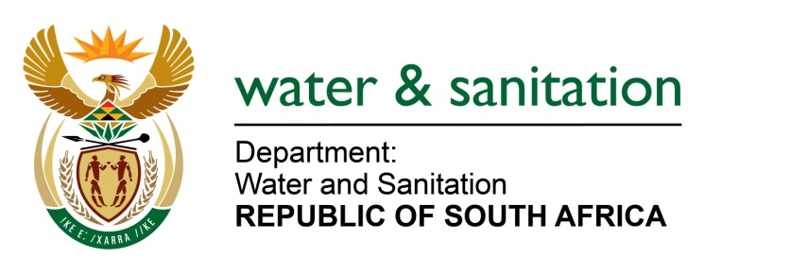

NATIONAL ASSEMBLY

FOR WRITTEN REPLY

QUESTION NO 3391

DATE OF PUBLICATION IN INTERNAL QUESTION PAPER: 23 SEPTEMBER 2022
(INTERNAL QUESTION PAPER NO. 36)

3391. Mr D F Mthenjane (EFF) to ask the Minister of Water and Sanitation:
(1) Whether his department undertook any studies to find out the reasons that water scarcity affects mainly rural areas where only black poor persons stay, but not the suburbs where rich persons stay; if not, what is the position in this regard; if so,
(2) whether he has found that this was by design; if not, what is the position in this regard; if so, what (a) are the relevant details of the findings and (b) is being done to reverse the situation?
NW4199E
---00O00---

MINISTER OF WATER AND SANITATION

- South Africa is a water scarce country, where everyone is affected by the limited water resources. My department undertakes various water resources and services planning studies and implements interventions or programmes to provide water to all citizens.

Due to the holistic and inclusive approach, areas that had historically been unserved have gradually seen service level improvements, as shown from the STATSSA data reflected in the General Household Survey. Much remains to be done, but a lot has been accomplished.

- The General Household Survey (GHS 2021) figures for basic water supply reflect a figure of 88% (64% in 1994) limited coverage of water infrastructure in South Africa. That is, drinking water from an improved source provided collection time is not more than 30 minutes for a roundtrip including queuing
- The General Household Survey (GHS 2021) figures for basic Level of Service is currently at 83% (49% in 1994). This includes use of improved facilities which are not shared with other households.

The Water and Sanitation Master Plan launched by the Department in 2020; is the blueprint that was developed to identify key actions and allocate roles and responsibilities to all stakeholders in the water sector, including the various tiers of government, and the private sector. It is intended to guide the sector regarding investment planning for the development of water resources, delivery of water and sanitation services, and addressing service delivery backlogs services until 2030. The Master Plan also addresses the enabling requirements, such as the institutional and legal arrangements for implementation, operation and maintenance, funding requirements and models, and monitoring and evaluation models.

- Although there are still evident backlogs in service delivery, particularly in rural areas; due to the legacy of apartheid; the democratic government has been turning the situation around by progressively ensuring access to water for all as mandated by the Constitution and the Bill of Rights. It should be noted that the population of South Africa has grown from 40 to 60 million which make the percentage progress even better due to the ever-moving target. The National Water and Sanitation Master Plan therefore comprises of key programmes, projects, and actions to be implemented for the protection and development of the national water resources, as well as provision of adequate and reliable water services for all citizens.

---00O00---

