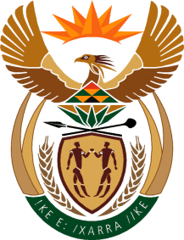

MINISTRY OF TOURISM
REPUBLIC OF SOUTH AFRICA

Private Bag X424, Pretoria, 0001, South Africa. Tel. (+27 12) 444 6780, Fax (+27 12) 444 7027
Private Bag X9154, Cape Town, 8000, South Africa. Tel. (+27 21) 469 5800, Fax: (+27 21) 465 3216

NATIONAL ASSEMBLY:
QUESTION FOR WRITTEN REPLY:
Question Number: 339
Date of Publication: 16 February 2018
NA IQP Number: 2
Date of reply:

Mr T Z Hadebe (DA) to ask the Minister of Tourism:

What amount did (a) her department and (b) each entity reporting to her spend on the promotion or celebration of the Year of O R Tambo on the (i) Africa News Network 7 channel, (ii) SA Broadcasting Corporation (aa) television channels and (bb) radio stations, (iii) national commercial radio stations and (iv) community (aa) television and (bb) radio stations since 1 January 2017? NW361E

- Department
The Department of Tourism has not spent any amount on the Year of Oliver Tambo

- SA Tourism
South African Tourism did not spend on the promotion or celebration of the Year of OR Tambo. In recognition of the significance of the year, South African Tourism weaved the message of the Year OR Tambo in most of their key spokesperson’s speaking engagements. These included the speeches at events such as:
Tourism Indaba (May 2017)
Tourism Month Launch (July 2017)
Tourism Month Celebrations (September 2017)
Lilizela National Awards (October 2017)
World Travel Market – UK (November 2017)

