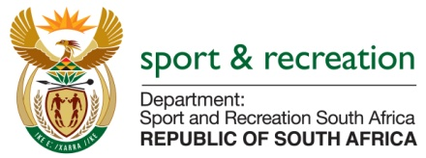

PARLIMENTARY QUESTION FOR THE MINISTER

QUESTION NO 3286

3286.​Mr P G Moteka (EFF) to ask the Minister of Sport and Recreation:
(1)​(a)(i) What total amount did his department spend on his travel costs between Gauteng and Cape Town in the 2014-15 financial year and (ii) how many trips did he undertake between Cape Town and Gauteng in the specified financial year and (b) what total amount did his department spend on (i) hotel and (ii) residential or other accommodation for him in (aa) Cape Town and (bb) Pretoria in the 2014-15 financial year;
(2)​(a)(i) what total amount did his department spend on the Deputy Minister’s travel costs between Gauteng and Cape Town in the 2014-15 financial year and (ii) how many trips between Gauteng and Cape Town did the Deputy Minister undertake in the specified financial year and (b) what total amount did his department spend on (i) hotel and (ii) residential or other accommodation for the Deputy Minister in (aa) Cape Town and (bb) Pretoria in the 2014-15 financial year?​NW3890E

REPLY

The Department requires additional time to respond to this question as the details required needs sufficient time to collate. The Department of Sport and Recreation has a very small finance Directorate and will not be able to respond to this question within the period allocated to reply to questions.

