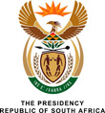

Question for Written Reply

3383. The Leader of the Opposition (DA) to ask the President of the Republic:
Whether he intends to make representations to the National Prosecuting Authority relating to the 783 counts of fraud, corruption and racketeering against him before the deadline of 30 November 2017; if so, (a) by which date and (b) what are the further relevant details? NW3775E
REPLY:
This matter is currently before the National Prosecuting Authority and I am taking legal advice.

