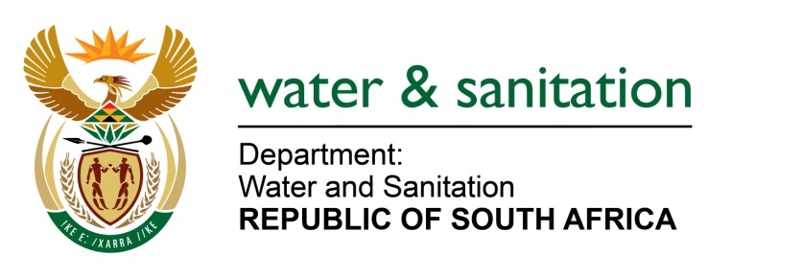

NATIONAL ASSEMBLY

FOR WRITTEN REPLY

QUESTION NO 3383

DATE OF PUBLICATION IN INTERNAL QUESTION PAPER: 4 SEPTEMBER 2015
(INTERNAL QUESTION PAPER NO. 35)

3383. Mr C D Matsepe (DA) to ask the Minister of Water and Sanitation:
Whether each water board in the country has an essential service agreement in place; if not, why not; if so, what are the relevant details of each such agreement? NW4042E
---00O00---
REPLY:

Amatola Water

Amatola Water does not have an existing agreement of essential services as this matter is currently being discussed at the Amanzi Bargaining Council in an attempt to have a standardised approach amongst all the Water Boards.

Bloem Water
Bloem Water has an Essential Services Agreement as negotiated with labour, facilitated by the Council for Conciliation Mediation and Arbitration (CCMA). The agreement specifies categories of employment designated as essential services such as treatment, security, pipeline teams and artisans. The Amanzi Bargaining Council is currently attending to an Essential Services framework as a guideline for adoption by respective water boards having identified their designated job categories.
Lepelle Northern Water

Lepelle Northern Water (LNW) does not have an Essential Service Agreement. This is due to the fact that organised Labour within LNW is refusing to engage on the same in order to sign one. Organised labour’s reason for refusal is that the agreement is divisive. In case of threatened industrial action we rely on clause 1 (d) of government gazette no 18276, vol 387 dated 12 September 1997 read together with chapter iv of the Labour Relations Act 66 of 1995 as amended.

Magalies Water

Magalies Water does not have an essential services agreement. A draft agreement is in place for all Water Boards at Amanzi Bargaining Council to be discussed at the next council meeting to be held on 17 September 2015.

Mhlathuze Water

Mhlathuze Water (MW) does not have an essential service agreement in place yet. An application was made to declare MW as essential service. After extensive investigation by the Essential Services Committee where presentations were made by MW and NEHAWU, MW was formally declared an essential service on 22 June 2015. The Essential Services Committee undertook to provide an essential service agreement to MW which is still awaited. Since Mhlathuze Water has been declared an essential service, all employees within Mhlathuze Water are deemed essential employees up until the minimum service level agreement is concluded.

Overberg Water
Overberg Water does not have an existing agreement of essential services in place. Engagements are currently planned with the Trade Unions, being the South African Municipal Workers Union and Independent Municipal and Allied Trade Union to establish an Essential Services Agreement.
Rand Water

Rand Water, by the nature of its mandate in terms of the Water Services Act, 108 of 1997, performs an essential service in supplying and distributing potable water in its area of supply. As far back as 2004, Rand Water and its Trade Unions at the time, being the South African Municipal Workers Union and the Rand Water Staff Association, established an Essential Services task team to investigate and determine which services are essential. The Rand Water Minimum Services Agreement was signed by all relevant parties on 30 September 2004. In terms of Section 70 of the Labour Relations Act, 66 of 1995 (as amended, the Rand Water Minimum Service Agreement was ratified by the Essential Services Committee of the CCMA in 12 January 2005.

In essence the agreement:

  - Indicates that parties commit to provision of essential services of providing water during any industrial action.
  - Defines Essential Service/s, Key Posts and Maintenance Service.
  - Has two annexures of specified positions that are required during strike action.
  - Directs parties to meet and consult on key posts.
However should there be, deviation or non-compliance to the agreement, Rand Water reserves its right to engage replacement staff.

Amanzi Bargaining Council, to which all water utilities belong, is in the process of developing an industry / sector wide “Minimum Services Agreement”.

Sedibeng Water

Sedibeng Water has a Minimum Service Agreement in place. The agreement provides for minimum services to be provided upon labour engaging on any strike action.

The agreement lists teams that are attached to Water Purification, Maintenance and Distribution functions of the organisation. The agreement ensures that water and sanitation services continue un-interrupted during the strike action.

Umgeni Water

Umgeni Water does not have a signed Minimum Service agreement, it still in a draft format which have been discussed with NEHAWU. We (The Department) are busy engaging NEHAWU to finalise the agreement.

---00O00---

