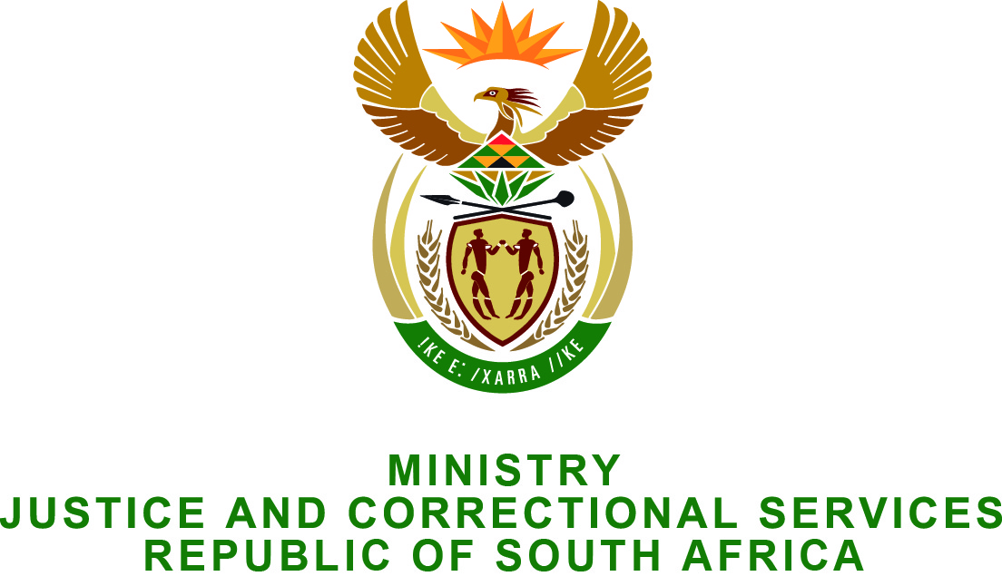

NATIONAL ASSEMBLY
QUESTION FOR WRITTEN REPLY
PARLIAMENTARY QUESTION NO: 3382
DATE OF QUESTION: 04 September 2015
DATE OF SUBMISSION: 18 SEPTEMBER 2015

Mr J Selfe (DA) to ask the Minister of Justice and Correctional Services:

Whether, in light of paragraph 39 of the judgment of Judge President D Mlambo in the case of the SA Litigation Centre versus the Minister of Justice and Correctional Services and 11 others, case number 27740/2015, the National Director of Public Prosecutions will institute criminal proceedings against any individuals; if not, why not; if so, (a) which individuals, (b) what will they be charged with and (c) when will they be charged? NW4041E

REPLY

The Respondents are appealing the matter. Judgment in the application for leave to appeal is awaited. As such, we deem it prudent for the appeal processes to be finalised before we consider the matter.

