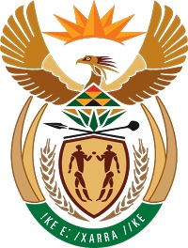
MINISTRY
COOPERATIVE GOVERNANCE AND TRADITIONAL AFFAIRS
REPUBLIC OF SOUTH AFRICA

NATIONAL ASSEMBLY
QUESTIONS FOR WRITTEN REPLY
QUESTION NUMBER: 3378
DATE OF PUBLICATION: 4 September 2015

Mr B M Bhanga (DA) to ask the Minister of Cooperative Governance and Traditional Affairs:
(1) (a) How many members currently serve on each traditional council and (b) how many of the specified members are women;
(2) What percentage of members of each traditional council were democratically elected;
(3) whether any traditional councils currently do not comply with sections 3(2)(b) and 3(2)(c)(ii) of the Traditional Leadership and Governance Framework Act, Act 41 of 2003; if so, (a) which traditional councils and (b) what has he done to address this?

NATIONAL ASSEMBLY
QUESTION FOR WRITTEN REPLY
QUESTION NUMBER: 3378

Reply:

The replies as received from the Provinces are specified in the attached table (Annexure A).

