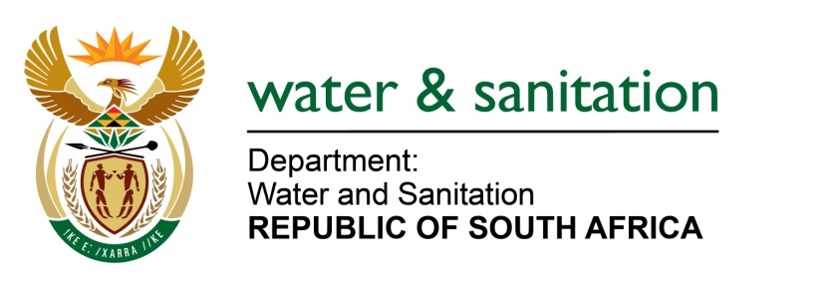

NATIONAL ASSEMBLY

FOR WRITTEN REPLY

QUESTION NO 3376

DATE OF PUBLICATION IN INTERNAL QUESTION PAPER: 4 SEPTEMBER 2015
(INTERNAL QUESTION PAPER NO. 35)

3376. MrsZ B N Balindlela (DA) to ask the Minister of Water and Sanitation:
(1) In terms of the latest information available to her department, (a) how many waste water treatment works are currently overflowing into nearby water bodies or areas, (b) where are they situated and (c) what is the severity of each spill;
(2) what system does her department utilise in order to (a) detect and (b) rapidly respond to sewage spillage and/or overflow from waste water treatment works? NW4035E
---00O00---
REPLY:
(1) The latest information with regard to spillages that have been reported is taken from those received from April 2015 to date. The number of cases reported to my Department are 19 and the cases are captured to include all the 9 provinces. Refer to Annexure A.

(2)(a) My Department through the various provincial offices undertake planned audits for the Waste Water Treatment Works (WWTWs) against their water use license, and also attend to queries received from consumers and those reported through the media as a means to attend to spillages resulting from the WWTWs, pumpstation and manholes.

(2)(b) In areas where spillages are as a result of manholes or pumpstation and municipalities have challenges to address the spillages, the rapid response unit is despatched to the affected municipality. However, Water Service Authorities (WSAs) are able to address spillages in-house if it’s detected early. In cases of a overflow from a WWTWs, nature of overflow dictates intervention and assistance needed. As a result the nature of the overflow will determine if the matter can be addressed rapidly or if it will require the plant to be upgraded to address the overflow.

In areas where it is as a result of overloading due to capacity constraint, such plants are prioritised through various support programmes of my Department for allocation of funds (Regional Bulk Infrastructure, Municipal Infrastructure Grand and Accelerated Community infrastructure programme) to upgrade the plants or in other cases refurbishment to ensure the plant operates efficiently with functional equipments that will be able to handle loading coming into the plant. The overflow as a result of design capacity constraint may not necessarily be addressed rapidly due to the fact that the upgrades are often multi year projects which take longer to construct before the overloading is completely addressed.
---00O00---

Annexure A
Region | Sector | Investigations & Inspections Reported | Investigations & Inspections Investigated or Inspected | Water User License Yes | Water User License No | Non-compliance Letters | Pre-directives | Severity of each case
Eastern Cape | Local Government [WSA/WSP] | 11 | 11 | 0 | 11 | 0 | 7 | Each cases reported were severe based on the fact that spillages reported has potential to pollute the environment hence pre-directives were issued.
Free State | Local Government [WSA/WSP] | 1 | 2 | 0 | 0 | 3 | 0 | Each cases reported were severe based on the fact that spillages reported has potential to pollute the environment
Gauteng | Local Government [WSA/WSP] | 2 | 2 | 0 | 2 | 0 | 0 | Cases reported were regarded to be severe based on the fact that spillages reported has potential to pollute the environment
Limpopo | Local Government [WSA/WSP] | 1 | 1 | 0 | 1 | 0 | 0 | Each cases reported were severe based on the fact that spillages reported has potential to pollute the environment
Mpumalanga | Local Government [WSA/WSP] | 1 | 2 | 0 | 1 | 0 | 1 | Each cases reported were severe based on the fact that spillages reported has potential to pollute the environment
North West | Government [National/Prov] | 0 | 2 | 0 | 0 | 0 | 1 | Each cases reported were severe based on the fact that spillages reported has potential to pollute the environment
North West | Local Government [WSA/WSP] | 2 | 1 | 0 | 2 | 0 | 0 | Each cases reported were severe based on the fact that spillages reported has potential to pollute the environment
Western Cape | Local Government [WSA/WSP] | 1 | 2 | 0 | 2 | 0 | 0 | Each cases reported were severe based on the fact that spillages reported has potential to pollute the environment
National | Local Government [WSA/WSP] | 19 | 23 | 0 | 21 | 3 | 10 | Cases reported not only for wastewater treatment works however also includes manholes that are close to streams and rivers. This has been taken with great urgency and prompted investigations that led to issuing of directives and put those affected WSAs under regulatory surveillance by the department.

