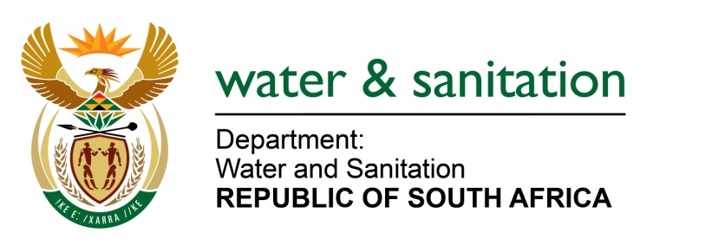

NATIONAL ASSEMBLY

FOR WRITTEN REPLY

QUESTION NO 3375

DATE OF PUBLICATION IN INTERNAL QUESTION PAPER: 23 SEPTEMBER 2022
(INTERNAL QUESTION PAPER NO. 36)

3375. Mr A Matumba (EFF) to ask the Minister of Water and Sanitation:
By what date will provisions for adequate water supply be made for residents of Makhado, in Louis Trichardt, who have been without water for a period of over three months?
NW4181E
---00O00---

MINISTER OF WATER AND SANITATION
Sources of water supply to Makhado in Louis Trichardt are the Albasini Water Treatment Works (WTW) and fourteen (14) supplementary boreholes. Of the fourteen (14) boreholes, only four (4) are currently operational asthe remaining ten (10) are non-functional as they have been vandalized. The design capacity of the WTW plant is 10ML/ day and is currently producing 7ML/day.
The Albasini Water Treatment Works was forced to shut down on 02 October 2022 due to failure of booster pump station number 3 and leaking of a galvanised pipe at the plant. This resulted in a shortage of water supply to Makhado. However, the repairs have been effected and the WTW has been functioning from 05 October 2022.
The DWS and the Vhembe District Municipality are currently constructing a bulk pipeline from Nandoni via Vuwani and Valdezia to Makhado to supply water to Makhado Area. The project scope includes the construction of a 88Km bulk pipeline, five reservoirs and three pumpstations.
Progress on the project is currently at 90% and completion is planned by March 2023. This project will also incorporate the Albasini water supply system, and replacement of the aged pipeline that is contributing to high water losses.
The department has initiated planning for the upgrade of Nandoni Water Treatment Works from 60Ml/d to 120ML/d to augment water supply as part of a long-term solution for water supply to the Makhado Area.
---00O00---

