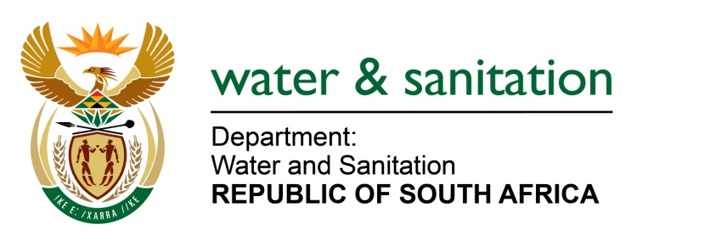

NATIONAL ASSEMBLY

FOR WRITTEN REPLY

QUESTION NO 3375

DATE OF PUBLICATION IN INTERNAL QUESTION PAPER: 4 SEPTEMBER 2015
(INTERNAL QUESTION PAPER NO. 35)

3375. Mrs Z B N Balindlela (DA) to ask the Minister of Water and Sanitation:
With reference to her media statement on 24 February 2015 on security of water supply (details furnished), (a) at what stage of development is the master plan for water resource infrastructure and (b) what is the estimated date of its completion? NW4034E
---00O00---
REPLY:
(a) The development of a Master Plan for water resource infrastructure is currently in the information gathering stage entailing aspects such as condition assessment of existing infrastructure and updating of the asset management plan.
It should be noted that the Second Edition of the National Water Resource Strategy that was published in 2013 already indicates key information on new water resource infrastructure projects that are currently under development and this shall form part of the master plan.
(b) The development of the Master Plan is estimated to be completed at the end of August 2016.
---00O00---

