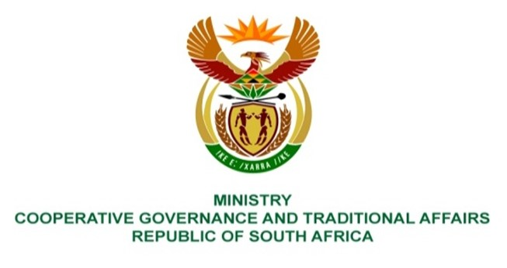

NATIONAL ASSEMBLY
QUESTION FOR WRITTEN REPLY

QUESTION NUMBER 3372
DATE OF PUBLICATION: 23 SEPTEMBER 2022

QUESTION:

3372. Mrs M R Mohlala (EFF) to ask the Minister of Cooperative Governance and Traditional Affairs:
What
(a) are the reasons that the Waterberg District Municipality in Limpopo is not a water authority
(b) municipality, entity and/or department is accountable for water provision in the Waterberg District; and
(c) total number of communities are affected by the water shortage in the specified district? NW4177E

REPLY:

The oversight role over water services institutions as per the Water Services Act is the responsibility of the Department of Water and Sanitation (DWS), and this question should be referred to that relevant Department for reply.

