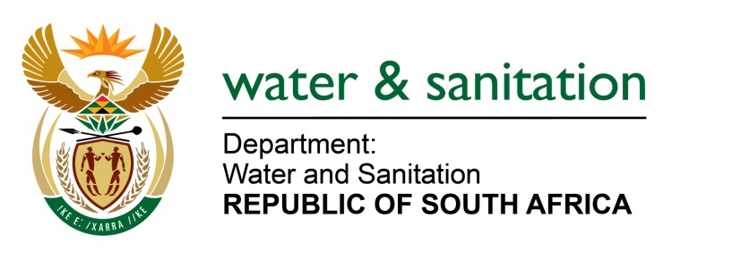

NATIONAL ASSEMBLY

FOR WRITTEN REPLY

QUESTION NO 3372

DATE OF PUBLICATION IN INTERNAL QUESTION PAPER: 4 SEPTEMBER 2015
(INTERNAL QUESTION PAPER NO. 35)

3372. Ms V van Dyk (DA) to ask the Minister of Water and Sanitation:
(1) Whether her department will intervene to address the malfunctioning waste water treatment works in Humansdorp in the Kouga Local Municipality in the Eastern Cape; if not, why not; if so, what are the relevant details;
(2) whether her department is aware of the disastrous conditions in Vergenoeg due to the spillages from the plant; if so, what plan has she put in place to address the specified matter;
(3) whether the specified plant was given a Green Drop score in the last reporting cycle; if not, why not; if so, what was the score;
(4) whether her department has taken any action against the specified municipality in terms of any legislation; if not, why not; if so, what are the relevant details? NW4031E
---00O00---

REPLY:

- No, my Department has not intervened on this matter yet. The Kouga Local Municipality (LM) is the Water Services Authority, Water Services Provider and owner of infrastructure and is responsible for undertaking the necessary upgrades. The Kouga LM has secured funding through the Department of Rural Development and Land Reform to upgrade the Kwa Nomzamo Waste Water treatment Works (WWTW). My Department will therefore not intervene until the Kouga LM has shown that they are unable to perform their functions.

My Department has reacted as regulator and catchment manager as follows:

- A non-compliance letter, dated 25 June 2015, was sent to Kouga LM addressing both the KwaNomzamo WWTW and the Koraal Pump Station. The Kouga LM responded with a reply dated 13 July 2015 (Refer to attached letter).
- A meeting was held on 24 July 2015 between the officials from my Department and the Kouga LM technical manager to get clarity and progress on this and other matters.

- Yes my Department is aware of the impact the failing WWTW is having on the environment and local communities; hence the actions taken.

The Kouga LM, in their response letter of 13 July 2015, has confirmed a partnership with the Department of Rural Development and Land Reform in 2013 to upgrade the WWTW; and on 3 June 2014 appointed a PSP to develop upgrade plans. On 4 March 2015 the Technical Report on the Refurbishment and Upgrading of the KwaNomzamo WWTW was received and is progressing to the tendering stage.

Regarding access control and fencing of the works, the Kouga Council approved a budget of R 2,0m to fence the said works. This project was approved by a full Council and a contractor has already been appointed in August 2015.

The Kouga LM is also working with local industries to ensure pre-treatment to reduce the organic and hydraulic load on the KwaNomzamo WWTW.

- The plant assessment was done during the last green drop assessment in 2013 and the plant received a score of 57.44%. This score placed the WWTW in the category ‘50% – 80% - Fair performance, ample room for improvement’.

- Yes, My Department has intervened from legal perspective as follows:

- A non-compliance letter, dated 25 June 2015, was sent to Kouga LM addressing both the KwaNomzamo WWTW and the Koraal Pump Station.
- Following their attached response dated 13 July 2015, a meeting was held on 24 July 2015 between the officials from my Department and the Kouga LM technical manager to get clarity and progress on this and other matters.

---00O00---

