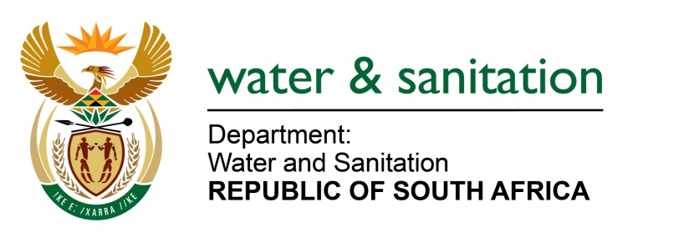

NATIONAL ASSEMBLY

FOR WRITTEN REPLY

QUESTION NO 3371

DATE OF PUBLICATION IN INTERNAL QUESTION PAPER: 4 SEPTEMBER 2015
(INTERNAL QUESTION PAPER NO. 35)

3371. Mr L J Basson (DA) to ask the Minister of Water and Sanitation:
(1) What is the status of the Wentzel Dam’s capacity to deliver water to Schweizer-Reneke in the North West;
(2) whether, given the fact that five of the 16 boreholes in Schweizer-Reneke are currently dry, she has taken any measures to prevent a water crisis in the event that the Wentzel Dam becomes empty and/or a dry season is experienced in the area? NW4030E
---00O00---
REPLY:

- The Wentzel Dam’s water level has dropped to 22% effective from end August 2015. The volume of water supplied from the Schweizer-Reneke Water Treatment Plant has also dropped from 4 Ml to 2.8 Ml per day. This has resulted in water supply shortages in Schweizer-Reneke Town and Ipelegeng Township.

The most affected are high-lying areas of Ipelegeng which are getting water intermittently during the night. To address this challenge, my Department in collaboration with water services authority, the Dr. Ruth Segomotsi Mompati DM, implemented the following short term interventions:
- The Fire and Disaster Unit from the Dr Ruth Segomotsi Mompati DM is on standby to supply water to the clinics and schools.
- Two water tanker trucks are currently supplying water to the most affected areas of Ipelegeng Extension 4, 6, 8 and portion of Extension 5.
- A total of 9X10 000 liters Jojo tanks are placed at Ipelegeng (including clinics, schools, police station) and are being filled from 06H00 until 20H00 on daily basis.

- My Department has allocated R5,1 million to Dr Ruth Segomotsi Mompati DM under the Municipal Water Infrastructure Grant (MWIG) for intervention in addressing the short term water supply issues. Already eight non-functional boreholes have been tested and the results have confirmed dewatering on the aquifers. The scope of work for this funding entails:
- rehabilitation and refurbishment of existing boreholes;
- sitting and drilling of new boreholes;
- equipping of boreholes; and
- connecting mains.

Furthermore, my Department allocated R1, 589 million to Dr. Ruth Segomotsi Mompati DM under Accelerated Community Programme (ACIP) to address Water Conservation Demand Management issues in Mamusa Local Municipality. The Dr. Ruth Segomotsi Mompati DM is in the process of getting Bid approval and the work is anticipated to commence in October 2015.

---00O00---

