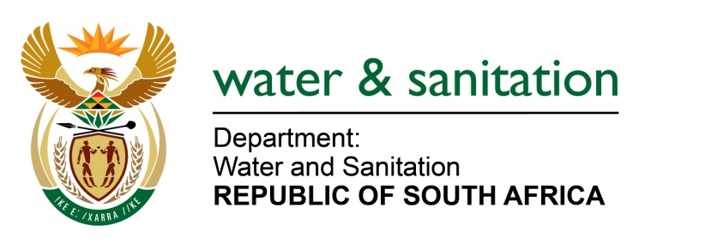

NATIONAL ASSEMBLY

FOR WRITTEN REPLY

QUESTION NO 3370

DATE OF PUBLICATION IN INTERNAL QUESTION PAPER: 4 SEPTEMBER 2015
(INTERNAL QUESTION PAPER NO. 35)

3370. Mr L J Basson (DA) to ask the Minister of Water and Sanitation:

(1) When will the construction of the pipeline from Bloemhof to Schweizer-Reneke in the North West (a) start and (b) be completed;

(2) (a) what will be the length of the pipeline and (b) how many mega litres of water will be transported per day, (c) what is the cost of the pipeline and (d) how will it be funded;

(3) whether the total cost of the project is already funded; if not, (a) why not and (b) how will it be funded; if so, what are the different (i) amounts and (ii) sources of funding;

(4) whether she received an approval from the SA National Roads Agency Limited (Sanral) regarding the construction of the pipeline over their property; if not, why not; if so, what are the relevant details;

(5) whether there exists an alternative plan for the pipeline if Sanral does not approve the planned construction on its land; if not, why not; if so, what are the relevant details? NW4029E

---00O00---
REPLY:

(1)(a) The construction of the pipeline will commence in March 2016.

(1)(b) The construction of the pipeline will be completed end of September 2016.

(2)(a) The length will be a 72 km and 350 mm diameter pipeline

(2)(b) 6.5 mega litres per day.

(2)(c) The total cost of the pipeline is R 72 million.

(2)(d) It will be funded by my Department through the Regional Bulk Infrastructure Grant (RBIG).

(3) Yes, the total cost of the project which is R403 million is already budgeted through RBIG in MTEF period

(3)(a) Falls away.

(3)(b) Falls away.

(3)(b)(i) Falls away.

(3)(b)(ii) Falls away.

(4) Yes, the SA National Roads Agency Limited (Sanral) granted approval for servitude.

(5) Falls away.
---00O00---

