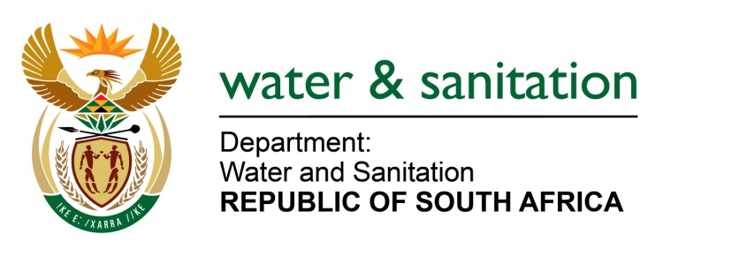

NATIONAL ASSEMBLY

FOR WRITTEN REPLY

QUESTION NO 3369

DATE OF PUBLICATION IN INTERNAL QUESTION PAPER: 4 SEPTEMBER 2015
(INTERNAL QUESTION PAPER NO. 35)

3369. Mr L J Basson (DA) to ask the Minister of Water and Sanitation:
(1) (a) When will the new water purification plant in Bloemhof in the North West be completed and (b) what will the capacity of the plant be;
(2) (a) what is the total cost of the specified plant and (b) how will it be funded;
(3) whether any outstanding funding is required to complete the project; if so, (a) what amount and (b) how will it be financed;
(4) who will be running the specified plant;
(5) which areas will receive water from the specified plant? NW4028E

---00O00---

REPLY:

(1)(a) The new water purification plant in Bloemhof in the North West will be completed in January 2017.
(1)(b) The capacity of the plant is from 10 Mℓ/d to 25 Mℓ/d.
(2)(a) The total cost of the plant is R403 million.
(2)(b) It will be funded by my Department through Regional Bulk Infrastructure Grant (RBIG).
(3) No outstanding funding is required.
(3)(a) Falls away.
(3)(b) Falls away.
(4) The plant will be operated by Sedibeng Water Board on behalf of Dr Ruth Segomotsi Mompati District Municipality.
(5) The following areas will receive water from the plant.
- ScheizerReneke Town;
- Ipelegeng Township;
- Bloemhof Town; and
- Boitumelong Township.
---00O00---

