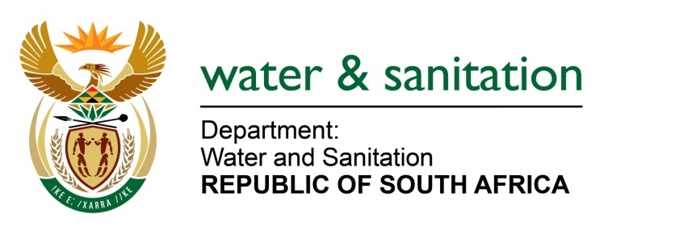

NATIONAL ASSEMBLY

FOR WRITTEN REPLY

QUESTION NO 3464

DATE OF PUBLICATION IN INTERNAL QUESTION PAPER: 30 SEPTEMBER 2022
(INTERNAL QUESTION PAPER NO. 37)

3464. Ms S A Buthelezi (IFP) to ask the Minister of Water and Sanitation:

(1) Whether his department has conducted recent investigations into the state of water and sanitation infrastructure in the municipalities that have either collapsed or are close to collapse; if not, why not; if so, what are the relevant details;

(2) whether his department has made additional funding available for the maintenance of the water and sanitation infrastructure for the specified municipalities; if not, why not; if so, what are the relevant details?

NW4269E
---00O00---

MINISTER OF WATER AND SANITATION

- The Department of Water and Sanitation (DWS) carries out a number of assessments into the state of water and sanitation infrastructure in the municipalities. These assessments enable the DWS to monitor the condition of municipal water and sanitation infrastructure through three incentive-based regulatory mechanisms:
- The Green Drop Report, which focuses on sanitation (waste-water treatment systems and effluent quality)
- The Blue Drop Report, which focuses on water (water treatment and water quality)
- The No Drop Report, which focuses on non-revenue water and water losses through leakages

Findings of the 2022 Green Drop report 2022 indicated that 334 Wastewater Treatment Systems have been identified to be at critical state by achieving less than 30% during Green Drop Assessment. Letters of non-compliance in terms of green drop report audit findings have been sent to respective water services institutions responsible for the systems at critical state, requiring them to submit a detailed corrective action plans. To date, eighteen (18) municipalities responsible for 81 wastewater treatment systems have submitted action plans. The Department has also collaborated with SALGA and MISA to assist municipalities on the development of action plans.

In line with the National Water Resource Strategy and National Water and Sanitation Masterplan, the Department has also revived the No Drop Programme to facilitate the reduction of Non-Revenue Water and Actual Water Losses. Findings of the No Drop progress report will be published in March 2023. The department is also currently in the process of undertaking blue drop assessments in 1186 water supply systems. The final Detailed Blue Drop Report is targeted for release in March 2023.

The DWS also monitors the capacity of municipalities to deliver water and sanitation through the Municipal Strategic Self-Assessment (MuSSA); a web-based system that enables municipalities to conduct their self-assessment on critical aspects service delivery performance. The outcomes of the assessment position the Department and other sector role players to provide targeted support to local government through various support and intervention programmes aimed at improving services delivery, governance and business health. Priority areas are identified and addressed through the development of a Municipal Priority Action Plan (MPAP).

Lastly, Five-Year Reliability Water and Sanitation Plans will soon be rolled out in all forty-four (44) District Municipalities. The plans are meant to:
- Ensure sustainable and reliable water services with the service-standard yardstick that has a 100% compliance to functionality, water security and effective governance to maintain appropriate levels of service delivery
- Conduct primary situational assessments of the water services and infrastructure supply conditions and classify each situation into a reliability category. The solution options are then integrated to proposed projects, specifically integrating all funding programmes to alleviate new infrastructure needs and achieve reliability of water services.

- According to Division of Revenue Act and grants frameworks, the Regional Bulk Infrastructure and Water Services Infrastructure Grants; managed by the DWS; do not fund any works related to operation and maintenance.

The department is looking at the current conditions of certain infrastructure and approached National Treasury to repurpose some portion of Regional Bulk Infrastructure and Water Services Infrastructure Grants to assist in the operation and maintenance of infrastructure.

---00O00---

