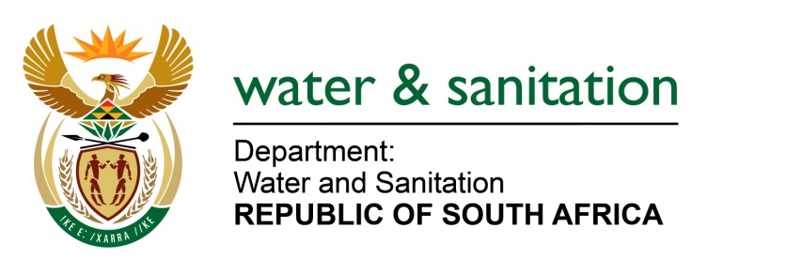

NATIONAL ASSEMBLY

FOR WRITTEN REPLY

QUESTION NO 3360

DATE OF PUBLICATION IN INTERNAL QUESTION PAPER: 4 SEPTEMBER 2015
(INTERNAL QUESTION PAPER NO. 35)

3360. Mr A R Mcloughlin (DA) to ask the Minister of Water and Sanitation:
In light of the fact that her department is mandated to discharge the Constitutional obligation of providing access to water to every citizen in the country, (a) what (i) joint discussion process has been established with the Department of Human Settlements and the Department of Cooperative Governance and Traditional Affairs, to ensure that no duplication or overlap of functionality in the carrying out of her department’s stated mandate occurs between these departments, (ii) separate actions are being taken by her department in carrying out its stated mandate, (iii) monitoring procedure is in place, to establish whether or not there is a duplicity of actions between departments, (iv) resolution mechanism exists in instances where two or more departments are found to be carrying out the same actions to ensure that optimal use is made of the available funds and (v) good reason exists for the continuation of this right that is shared by the specified departments and (b) why should the right of water provision not be located within one dedicated department? NW4019E
---00O00---
REPLY:

(a)(i) A joint discussion has already taken place between the Department of Water and Sanitation together with COGTA, the Municipal Infrastructure Support Agent (MISA), the office of the Presidency’s M&E unit and National Treasury, and a Project Management Office (PMO) has been established to co-ordinate and integrate all water services activities related to sustainable Water Services delivery in the 27 Priority DMs. The Department of Human Settlements is part of this initiative. The PMO will ensure that there is no duplication with regards to the water and sanitation service delivery and will ensure that funding alignment between different Departments and funding sources takes place.

(a)(ii) No separate actions are being undertaken by the Department. As stated above all water services actions are being coordinated through the PMO.

(a)(iii) A monitoring programme is being established to ensure that, once a pipeline of projects has been determined, they are implemented and run effectively. My Department has identified eleven key intervention activities that will be monitored to ensure the implementation of sustainable water and sanitation service delivery. They are:
- Demographics;
- Service Levels;
- Socio-Economics;
- Water Services Infrastructure;
- Operational and Maintenance;
- Associated Services;
- Water Resources;
- Conservation & Demand Management;
- Financial;
- Institutional Arrangements; and
- Social & Customer Service Requirements.
-2-

A 5-year implementation plan will be developed and implementation thereof will be monitored at community and project level. The plan will be developed through a consultancy process at municipal level with relevant role-players and funding initiatives. The plan will be signed off by Council to ensure that no duplication takes place.

(a)(iv) Requesting Honourable member to note that, there are no two Departments which execute identical actions. Each Department finds its mandate in the Constitution, followed by the legislation administered by the respective Department, therefore the need for such a resolution mechanism has not arisen. My Department's mandate is highlighted in Section 3 of the National Water Act, 1998 (Act No. 36 of 1998):

“Public trusteeship of nation's water resources
3. (1) As the public trustee of the nation's water resources the National Government, acting through the Minister, must ensure that water is protected, used, developed, conserved, managed and controlled in a sustainable and equitable manner, for the benefit of all persons and in accordance with its constitutional mandate. (2) Without limiting subsection (1), the Minister is ultimately responsible to ensure that water is allocated equitably and used beneficially in the public interest, while promoting environmental values. (3) The National Government, acting through the Minister, has the power to regulate the use, flow and control of all water in the Republic.”

(a)(v) Falls away.

(b) Falls away.
---00O00---

