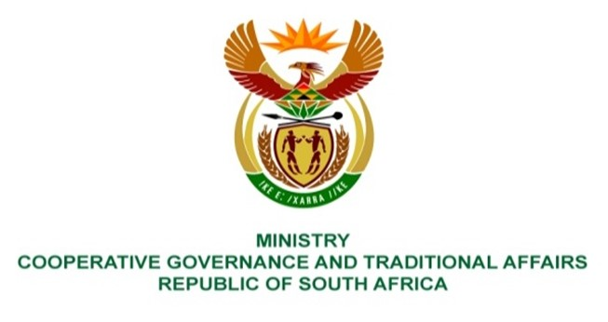

NATIONAL ASSEMBLY
QUESTIONS FOR WRITTEN REPLY
QUESTION NUMBER: 336

336. Mrs S M Mokgotho (EFF) to ask the Minister of Cooperative Governance and Traditional Affairs:
Whether her department intends taking any intervention measures under the provisions of the Constitution of the Republic, 1996, to assist the community of Siyahlala Informal Settlement in the Western Cape, which has been struggling without basic service delivery for a prolonged period of time; if not, why not; if so, what are the relevant details? NW351E
REPLY:
The Western Cape is home to multiple Siyahlala Informal Settlements. In order for the department to investigate and respond, it is advised that the Honourable member make it clear for which town or municipality the informal settlement in question is situated.
End.

