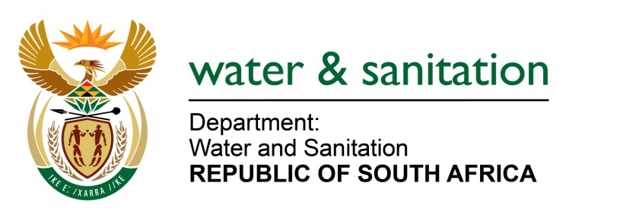

NATIONAL ASSEMBLY

FOR WRITTEN REPLY

QUESTION NO 3353

DATE OF PUBLICATION IN INTERNAL QUESTION PAPER: 4 SEPTEMBER 2015
(INTERNAL QUESTION PAPER NO. 35)

3353. Mr R A Lees (DA) to ask the Minister of Water and Sanitation:
(1) What are the reasons for not supplying piped water to the Mazizini area situated in Ward 6 of the Okhahlamba Local Municipality and within the uThukela District Municipality in KwaZulu-Natal, which has been without piped water for six months;
(2) whether her department has made alternative arrangements to supply water to the community; if not, why not;
(3) whether her department (a) has taken or (b) will take action in order to reinstate piped water supplies to the specified area; if not, why not; if so, (i) what action has been taken and (ii) when will the supply of piped water be restored to the specified area? NW4010E

---00O00---
REPLY:

- The Mazizini area collectively comprises of two communities, the Newstand and Obonjaneni communities.

The Obonjaneni community currently has no interruptions in water supply and receives piped water from a reservoir which is fed from the KwaMfalazi River. The water is chlorinated at the reservoir.

The Newstand community in Ward 6 is normally supplied by a reservoir which is fed from the Zwelitsha Water Treatment Works (WTW). However, the Zwelitsha WTW currently does not have sufficient capacity to meet the demands of both the Zwelitsha and the Newstand areas.

The Uthukela District Municipality (DM) has therefore opted to supply the affected Newstand Community with water through a production borehole. The water from the production borehole was being pumped into the existing reservoirs which then supplied the community through the existing reticulation network. However, due to the drought currently being experienced in the Kwazulu-Natal Province, the groundwater levels have dropped substantially and there has been very little water in the borehole to pump. This resulted in the pump running dry which caused damage to the pump and the subsequent collapse of the pipe work within the borehole thus leaving the community without piped water supply for the past 6 months. This production borehole will therefore need to be replaced.

(2) The area currently has two (2) functional hand pump boreholes which are supplying approximately 900 community members with water as a temporary measure. These boreholes do not meet the full needs of the community and the Uthukela DM will be deploying water tankers to the area to fill up the reservoirs twice on a weekly schedule.

(3)(a) Yes, my Department has taken steps to reinstate piped water supplies to the area.

(3)(b)(i) As an interim measure the UThukela DM has appointed a service provider to investigate the availability of groundwater in the area and drill additional production boreholes for supply to the affected community.

(3)(b)(ii) This work is planned to commence within September 2015. The Zwelitsha WTW requires an upgrade in order to meet the required demands of both the Zwelitsha and Newstand areas. There is a planned upgrade by the Uthukela DM to increase the Zwelitsha WTW capacity scheduled to start in December 2015.

---00O00---

