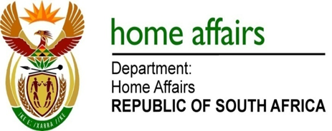

NATIONAL ASSEMBLY

QUESTION FOR WRITTEN REPLY

QUESTION NO. 3352

Mr P G Moteka (EFF) to ask the Minister of Home Affairs:

Whether (a) she or (b) her Deputy Minister made use of a chartered private jet during the period 1 January 2013 up to the latest specified date for which information is available; if so, what (i) were the reasons for using a chartered private jet, (ii) was the travel route in each case and (iii) did the use of the jet cost the department in each case? NW3743E

REPLY:

(a) Yes, details thereof have been covered in the Annual Report of the Department of Home Affairs tabled in Parliament. (b) No. The Deputy Minister has not made use of a chartered private jet

