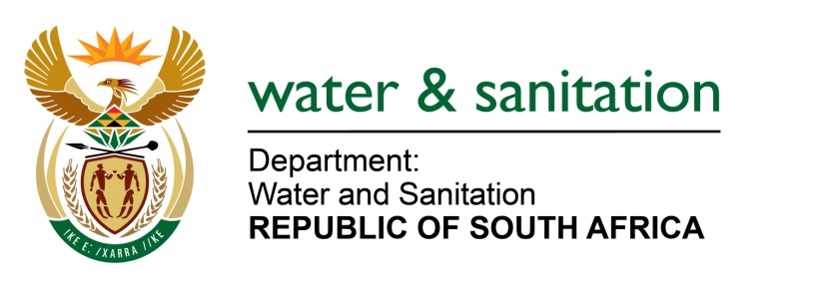

NATIONAL ASSEMBLY

FOR WRITTEN REPLY

QUESTION NO 3352

DATE OF PUBLICATION IN INTERNAL QUESTION PAPER: 4 SEPTEMBER 2015
(INTERNAL QUESTION PAPER NO. 35)

3352. Mr R A Lees (DA) to ask the Minister of Water and Sanitation:
(1) What are the reasons for the non-supply of piped water to the Divaal area situated in Ward 2 of the Indaka Local Municipality and within the uThukela District Municipality in KwaZulu-Natal, which has been without piped water for six months;
(2) whether her department has made alternative arrangements to supply water to the community; if not, why not;
(3) whether her department (a) has taken or (b) will take action in order to reinstate piped water supplies to the specified area; if not, why not; if so, (i) what action has been taken and (ii) when will the supply of piped water be restored to the specified area? NW4009E
---00O00---
REPLY:

- The Uthukela District Municipality (DM) is the Water Services Authority responsible for providing water services in the Indaka Local Municipality (LM). The area is supplied through the Ekukeveni Water Scheme and the Oliphantskop Dam is the raw water source.

The Divaal area has not been without piped water supply for any extended period. The entire Indaka area has an interrupted water supply i.e. the water supply is not available on a continuous basis due to a shortage of water. The water demand exceeds the available water supply because the Ekuvukeni Water Scheme was designed for a particular area and water demand, however more areas were brought onto and supplied from this water scheme, exceeding the scheme’s design capacity.

The different areas of Indaka LM receive piped water on a rotational basis with each area receiving water supply on different days of the week. Some areas, receive water more than once a week depending on location in the area. This is influenced by the proximity to the water treatment works and the layout of the water scheme. The Divaal area is at the end of the water scheme and receives water once a week on Thursdays.
(2) When an area is not receiving water through the water scheme, the Uthukela DM provides water tankers to fill static water tanks and individual containers so residents have access to water.
(3)(a) The Uthukela DM has identified and is implementing a range of measures to ensure continuous piped water supply in the area.
(3)(b)(i)As part of the drought intervention programme, which is managed by my Department, the UThukela DM is allocated R3 million to implement a borehole programme to improve water availability in the district. Contractors are currently on site conducting investigation of sites to start drilling boreholes. The Uthukela DM has made a further application for R3.5 million under the Municipal Water Infrastructure Grant to extend the borehole programme in this area.
(3)(b)(ii)The long term sustainable solution depends on the rollout of the Driefontein Complex Regional Bulk Scheme, a Regional Bulk Infrastructure Grant funded project with various phases to ultimately supply water to the region from the Spioenkop Dam.
---00O00---

