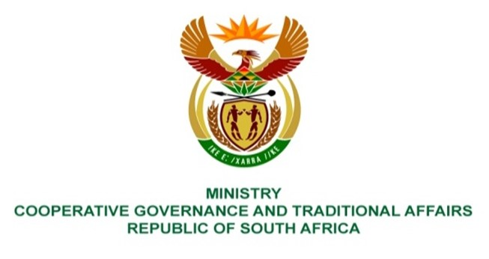

NATIONAL ASSEMBLY
QUESTIONS FOR WRITTEN REPLY

QUESTION NUMBER 335
DATE OF PUBLICATION: 17 FEBRUARY 2023

335. Mrs S M Mokgotho (EFF) to ask the Minister of Cooperative Governance and Traditional Affairs:
Whether she intends to put any intervention measures in place under the provisions of the Constitution of the Republic, 1996, to provide relief to residents of the City of Ekurhuleni Metropolitan Municipality who are currently experiencing delays regarding refuse removal; if not, why not; if so, what are the relevant details? NW350E
REPLY:
The Portfolio Committee on Cooperative Governance and Traditional Affairs convened a meeting with the City of Ekurhuleni on the 2nd September 2022, to engage the Executive and Senior management on petitions, amongst which the matter of refuse removal was discussed. The Metro indicated their constraints (financial and tools of trade) towards sufficiently servicing communities on refuse removal, amongst other services. In response, a medium to long-term mitigation plan was tabled to remedy the situation, which would have been shared with the Portfolio committee.
Based on the details provided in the foregoing engagement, the nature and extent of these challenges generally, particularly refuse removal, there is no trigger for a Constitutional “intervention”. However, further to the mitigation plan that the City tabled, both National and provincial governments continue to implement the provisions of Section 154 of the Constitution, in the form of a Gauteng ‘Local Government Support Framework’ anchored around Multi-Disciplinary Regional Support Teams (inclusive of Sector Departments) and implementation of Regional Support Plans. This plan is monitored on an ongoing basis and reported to Cabinet as part of the State of Local Government report (SOLG) and the Portfolio Committee. End.

