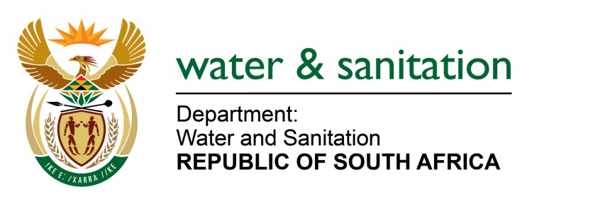

NATIONAL ASSEMBLY

FOR WRITTEN REPLY

QUESTION NO 3347

DATE OF PUBLICATION IN INTERNAL QUESTION PAPER: 23 SEPTEMBER 2022
(INTERNAL QUESTION PAPER NO. 36)

3347. Mrs E R Wilson (DA) to ask the Minister of Water and Sanitation:
(1) With reference to the sewerage plants in Musina, Makhado and Ephraim Mogale Local Municipality in Limpopo being altogether dysfunctional and spewing raw sewerage into rivers and water supplies in the towns and surrounding areas, resulting in the contamination of rivers, drinking water, irrigation dams and affecting the health of livestock in all areas, what (a) number of complaints has his department received with regard to the crisis and (b) actions have been taken against the municipalities, district municipalities and Lepelle Northern Water, to hold them accountable for the health risks, damage to the environment and losses of exportable crops and livestock;
(2) what actions have been taken to ensure that the (a) crisis is immediately rectified and that sewerage plants are made properly functional and (b) rehabilitation of surrounding areas including underground water, rivers, irrigation dams, is urgently attended to;
(3) what funds have been made available to compensate for losses and/or health issues of members of the public and businesses as a result of the incompetence of the municipalities and Lepelle Northern Water?
NW4152E
---00O00---

MINISTER OF WATER AND SANITATION

- The Musina and Makhado Local Municipalities (LM) fall within the jurisdiction of Vhembe District Municipality (VDM). The VDM is the Water Service Authority (WSA) and Water Service Provider (WSP) to the two local municipalities. A total of three (3) complaints were received regarding (i) two (2) sewer spillages from manholes in the Makhado and Musina and; (ii) uncontrolled discharge of effluent from the Harper wastewater treatment works (WWTW) which is disturbing the construction of a nearby road. Both incidents from the manholes have since been resolved.
The 2022 Green Drop Report raised concerns regarding the overall poor state of wastewater services at Biaba, Waterval, Hlanganani, Makhado, Malamulele, Mhinga, Musina, Mutale, Nancefield, Rietvlei, Tshifulanani, Vleifontein and Vuwani systems and the consequential impact on respective water resources. A letter of non-compliance has been issued for the Water Services Authority to submit a detailed corrective action plan within 60 days of publishing the Green Drop Report. The plan must map the activities, responsible persons, timelines, and expected improvements as outlined in the Regulations. To date, no report has been received to date and the Department is engaging the WSA together with MISA and SALGA as indicated below.
In addition, the Department of Water and Sanitation (DWS) conducted compliance monitoring Inspections at Musina WWTW Nancefield (08 March 2022) and Rietvlei WWTW (07 March 2022) to check compliance against the conditions of issued water use licences for these WWTWs. An investigation was also conducted on the 18 August 2022 at the Campbell sewage package plant an to ensure compliance of National Water Act.
- The DWS has issued directives to VDM for non-compliance of the following wastewater systems that are under Musina and Makhado LMs:Musina WWTW and Nancefield WWTW - issued on the 25 March 2022
- Harper WWTW and Makhado WWTW - issued on the 06 September 2021
- Campbell sewage package plant - issued on the10 August 2022In response to the directives issued by the DWS, the Vhembe District Municipality has developed the corrective action plans to address challenges with the WWTWs. Actions to be taken by the VDM include:refurbishment of the WWTW systems
- Improvement operation and maintenance of the existing infrastructure
Furthermore, the DWS has approved business plans to fund the refurbishment projects through the Water Service Infrastructure Grant (WSIG) within the current financial year. The department is monitoring the implementation of the projects which are still at initiation stage and expected to be completed by end of municipal financial year 2022/23.
(2) Ephraim Mogale Local Municipality falls within the jurisdiction of Sekhukhune District Municipality (SDM) which assume responsibility of water and sanitation services as the WSA and WSP. Four complaints were received from Ephraim Mogale Local Municipality regarding pollution emanating from Wastewater Treatment Works (WWTW). Administrative actions were taken against Sekhukhune District Municipality as a Water Service Authority for Ephraim Mogale Local Municipality.

- Moganyaka Oxidation Ponds for which the DWSissued notice of intention to issue a directive dated 29 October 2021;– a follow up inspection was conducted on 15 June 2022 by the department who found that the issues identified in the notice had not been addressed. A directive is being prepared.

- Dennilton WWTW for which the DWS issued notice of intention to issue a directive dated 31 July 2019; the department conducted a follow up inspection on 08 June 2022 to ascertain compliance with the provisions of the NWA. The municipality was further non-compliant with the directive in terms of Sections 19(3) and 53(1) of the National Water Act, 1998 which is an offence in terms of Section 151(1)(d) of the NWA. The case has been referred for an interdict against Sekhukhune District Municipality to ensure compliance with the directive for the Dennilton WWTW. Therefore, the Department has opened a criminal case for offences outlined in Section 151(1)(d), (i) and (j)) of the NWA. The criminal case will be opened against the Sekhukhune DM.

- Nebo Oxidation Ponds in relation to a directive dated 04 May 2021; - DWS officials conducted a follow up inspection was conducted on 13 August 2020 and 05 November 2021 to ascertain compliance with a directive issued by the DWS. Most of the non-compliances had been rectified and the ponds were empty. The municipality indicated that the Oxidation Ponds will be utilized soon. The department officials recommended that the facility should be monitored continuously to ensure compliance with the directive issued to Greater Sekhukhune Municipality.

- Ephraim Mogale WWTW in relation to a notice of intention to issue a directive dated 29 December 2021; DWS officials conducted a follow up inspection on 15 June 2022 to ascertain compliance with the provisions of NWA. A directive will be issued.

- The 2022 Green Drop Report indicates that Marble Hall Wastewater system declined from a 62.3% score in 2013 to a 52% score in 2022. The inspectorate observed a lack of co-ordination amongst Lepelle Water (which is responsible for the Operation and Maintenance of four (4) WWTWs including Burgersfort, Groblersdal, Marble Hall, Steelpoort) and the WSA, which was noticeable during assessments. Plants operated by Lepelle Water achieved Green Drop scores of between 46% and 58% indicating a decline from 2013 Green Drop scores.
There were no compensation claims submitted to Vhembe DM regarding loss and/or health issues however the department availed funds to Vhembe DM through the Water Services Infrastructure Grant (WSIG) to refurbish and improve operations and maintenance of the wastewater systems.
---00O00---

