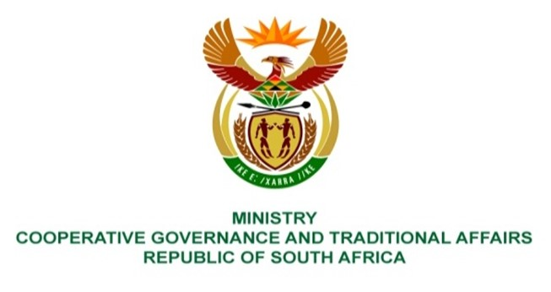

NATIONAL ASSEMBLY
QUESTION FOR WRITTEN REPLY

QUESTION NUMBER 334
334. Mr. T Mogale (EFF) to ask the Minister of Cooperative Governance and Traditional Affairs:
What steps have been taken to improve (a) infrastructure and (b) emergency response systems in high-risk flood zones? NW349E

REPLY:

- MISA is assisting municipalities in developing or reviewing the Spatial Development Frameworks (SDFs) and Land Use Plans which incorporates the review of the high flood lines and prohibiting future construction of infrastructure in flood prone areas, and wetlands. This minimises the risks of flood damage to infrastructure.

- The NDMC is strengthening its collaborative agreement with the South Africa Weather Service to improve on early warnings and early actions in the provinces and municipalities to safeguard communities against the recurrence of flooding incidents and damages.

End

